|  |  |
| --- | --- |
| **2Ex. No: 1** | **Git and GitHub** |
| **10-07-2024** |

**Aim:** To explore Git Commands through Collaborative Coding – Basic Git commands.

**Procedure:**

# Exploring Git Commands through Collaborative Coding – Basic Git commands.

* 1. Create a Repository
     + Setting Up Git Repository named “Master”



* 1. Add and Commit Changes
     + Create a new text file named ReadMe.txt using any text editor.



* 1. Exploring history
     + Modify/add content to the text file.

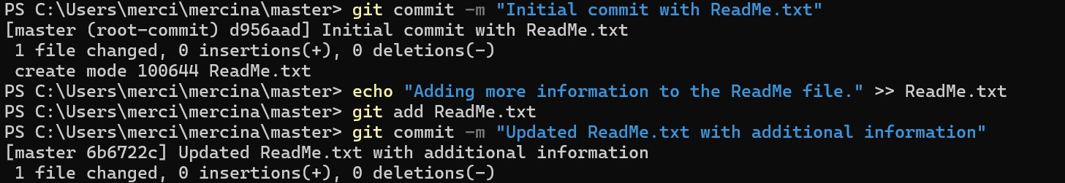

* 1. Branching and merging
     + Create a new branch named "Updated_ReadMe" and commit the changes in the branch.
     + Merge the changes from the Updated_ReadMe branch into the Master branch.

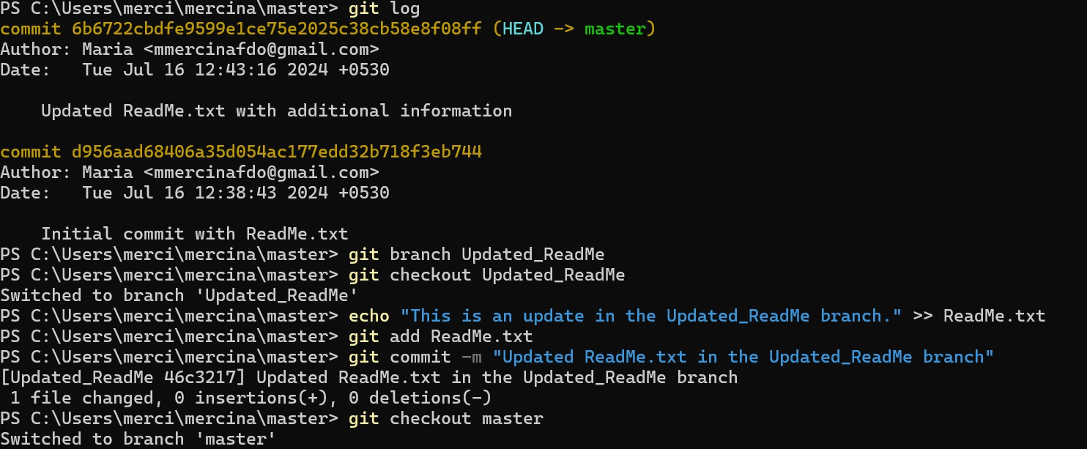

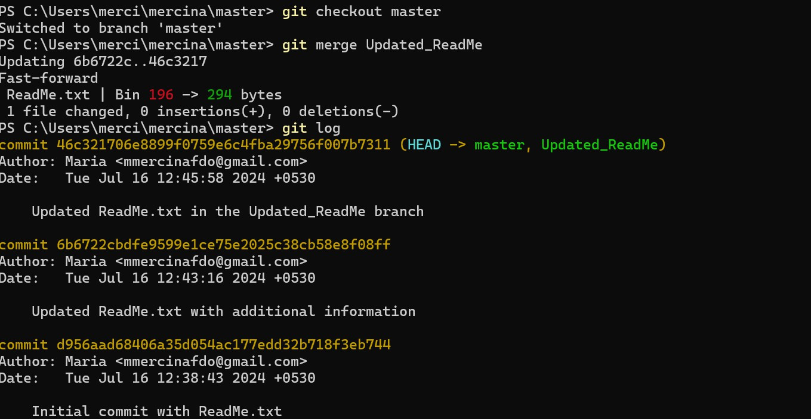

* 1. Collaborating with Remote Repositories
     + Link your local repository to the remote repository

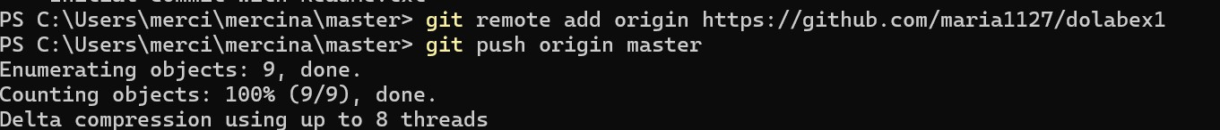

* 1. Push Changes
     + Push your local commits to the remote repository

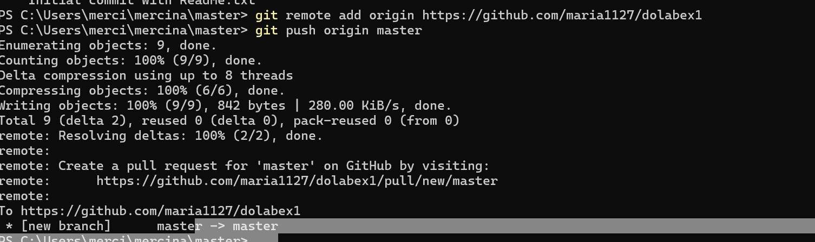

# Implement GitHub Operations using Git.

* 1. Cloning a Repository
     + Clone the repository of your project from github

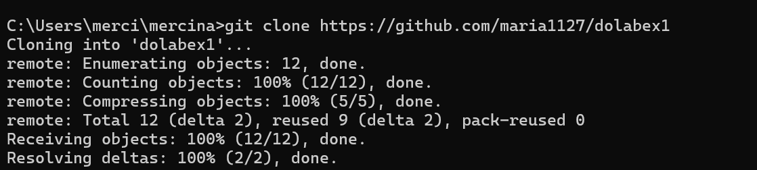

# Making Changes and Creating a Branch

* + - Navigate into the cloned repository, do the necessary changes and check the status of the repository

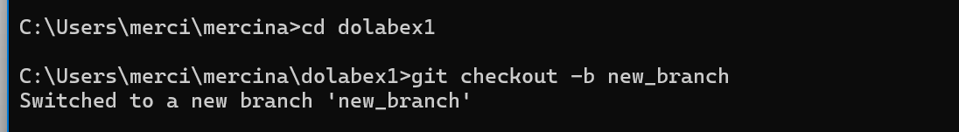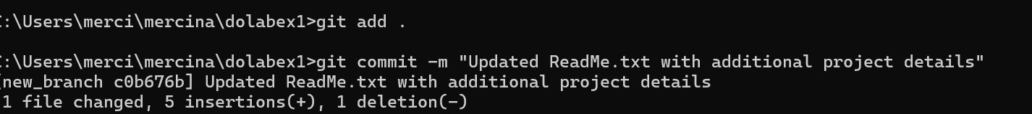

# Pushing Changes to GitHub

* + - Add Repository URL in a variable
    - Push the local branch to the repository

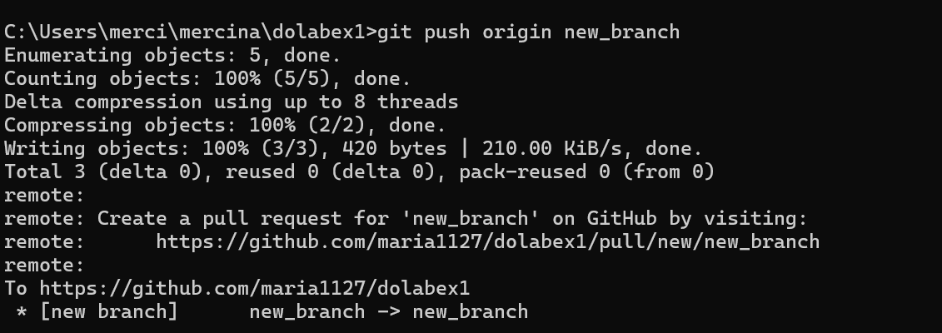

# Collaborating through Pull Requests

* + - Create a pull request on GitHub
    - Choose the base branch and compare it with the branch
    - Review the changes and merge the pull request.
    - Add a title and description for the pull request
    - Assign reviewers
    - Reviewers approve the pull request, merge it into the base branch.

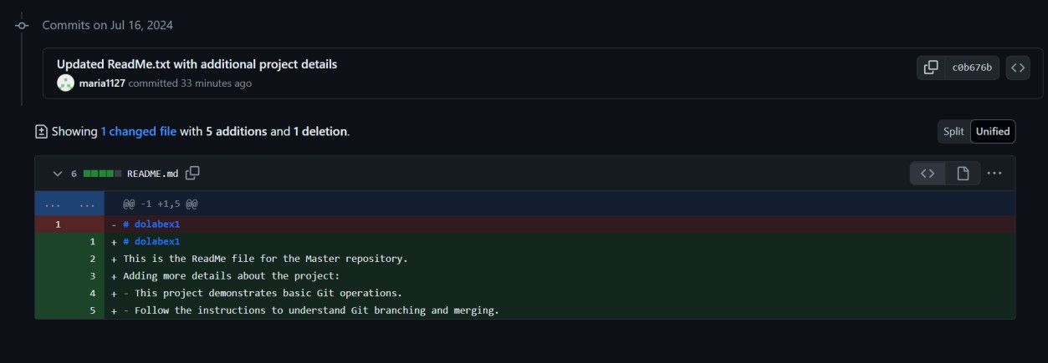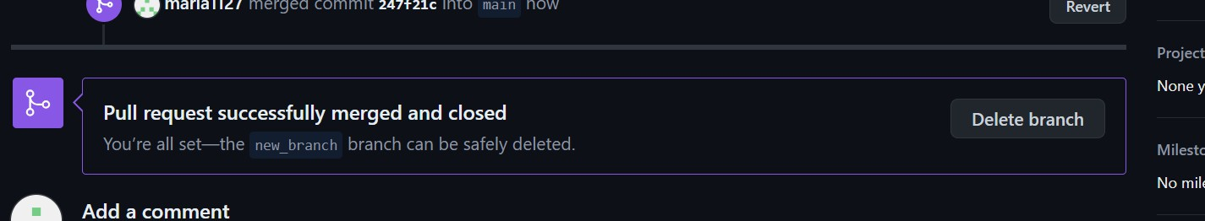

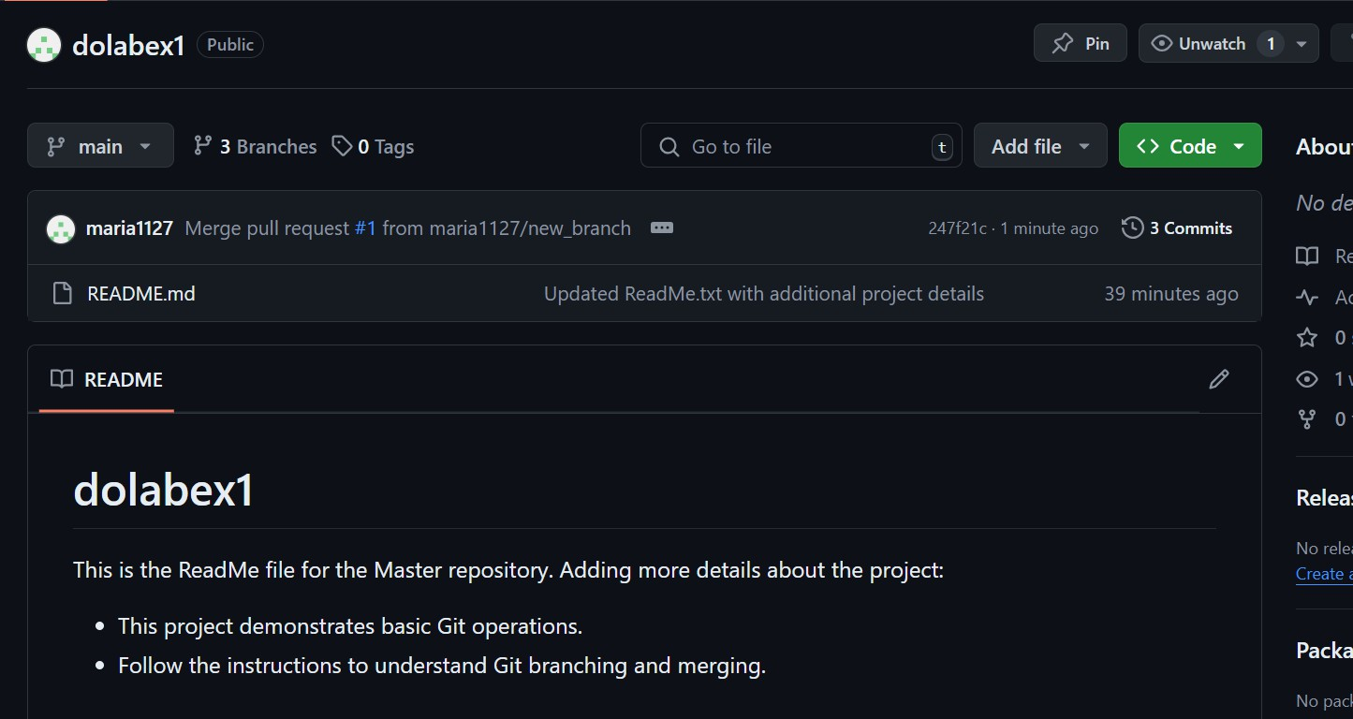_

# Syncing Changes

* + - After the pull request is merged, update your local repository

**Result:** The above procedure to explore Git Commands through Collaborative Coding

has been successfully executed.

|  |  |
| --- | --- |
| **Ex. No: 2** | **GitLab** |
| **06-06-2024** |

**Aim:** To implement GitLab Operations using Git.

**Procedure:**

* Creating a Repository
* Cloning a Repository
  1. Use git clone <repository_url> with the URL you copied from GitLab



* Making Changes and Creating a Branch
  1. Navigate into the cloned repository

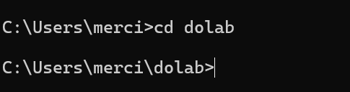

* 1. Create a new text file named "filename.txt" using a text editor.
  2. Add some content to the " filename.txt" file.

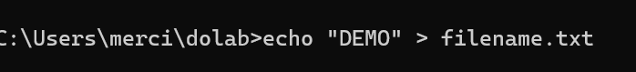

* 1. Save the file and return to the command line.
  2. Check the status of the repository

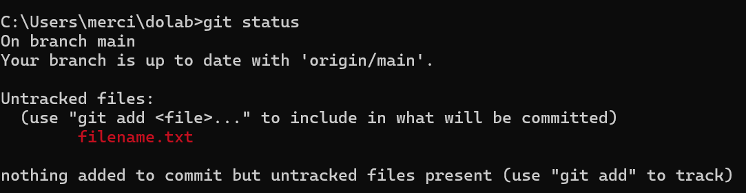

* 1. Stage the changes for commit

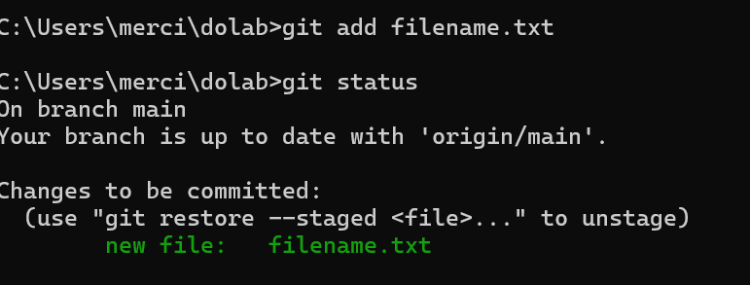

* 1. Commit the changes with a descriptive message "Edited_example.txt"

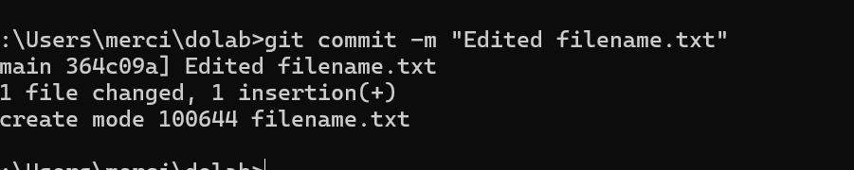

* 1. Create a new branch named "feature"
  2. Switch to the "feature" branch

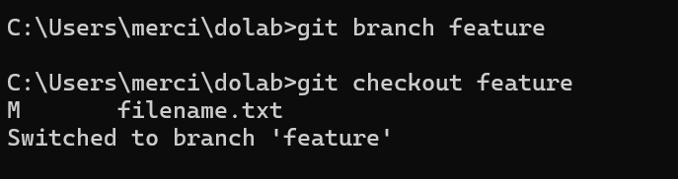

* 1. Pushing Changes to GitLab

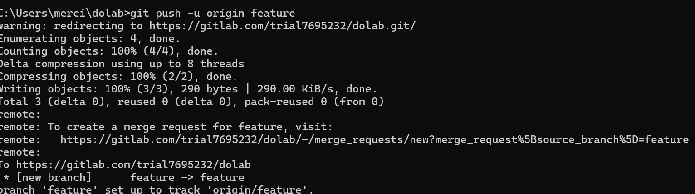

* Add Repository URL in a variable
  1. Add Repository URL in a variable
  2. Replace <repository_url> with the URL you copied from GitLab



* 1. Push the "feature" branch to GitLab
  2. Check your GitLab repository to confirm that the new branch "feature" is available.
* Collaborating through Merge Requests
  1. Create a merge request on GitLab
  2. Review and merge the merge request

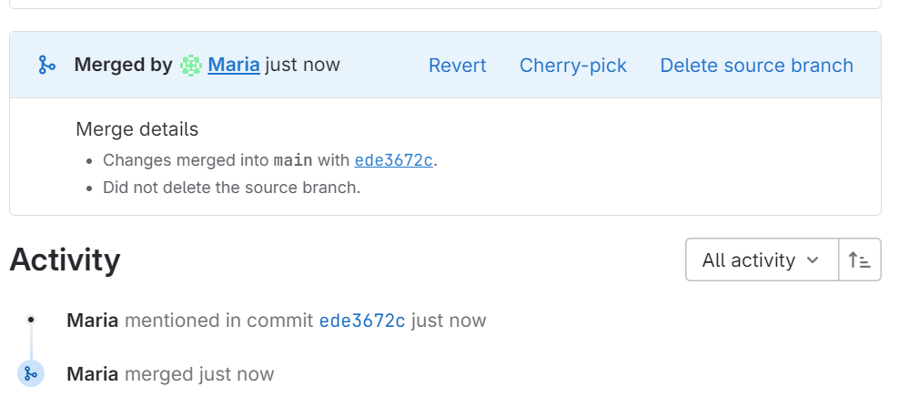

* Syncing Changes
  1. After the merge request is merged, update your local repository

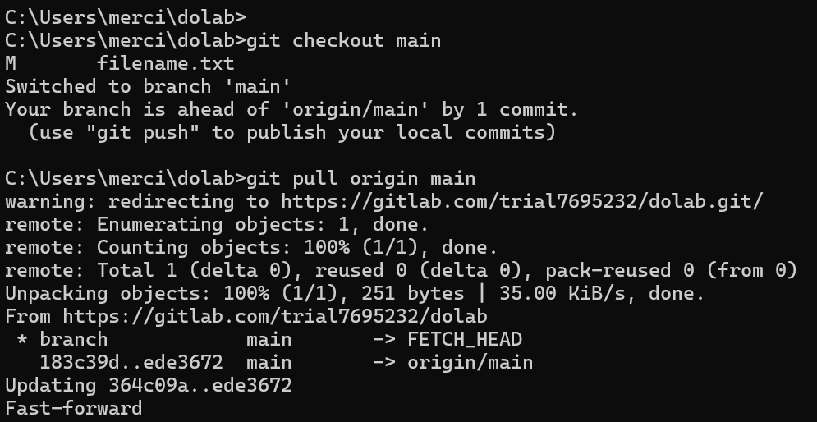

**Result:** The above procedure to implement GitLab operations using Git has been successfully executed.

|  |  |
| --- | --- |
| **Ex. No: 3** | **Bitbucket** |
| **06-08-2024** |

**Aim:** To implement Bitbucket Operations using Git.

**Procedure:**

* Creating a Repository
* Cloning a Repository
  1. Use git clone <repository_url> with the URL you copied from Bitbucket.

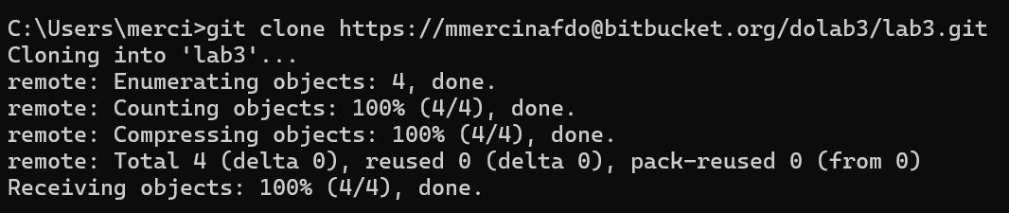

* Making Changes and Creating a Branch
  1. Navigate into the cloned repository

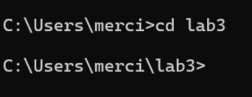

* 1. Create a new text file named "filename.txt" using a text editor



* 1. Add some content to the " filename.txt" file.
  2. Save the file and return to the command line.
  3. Check the status of the repository

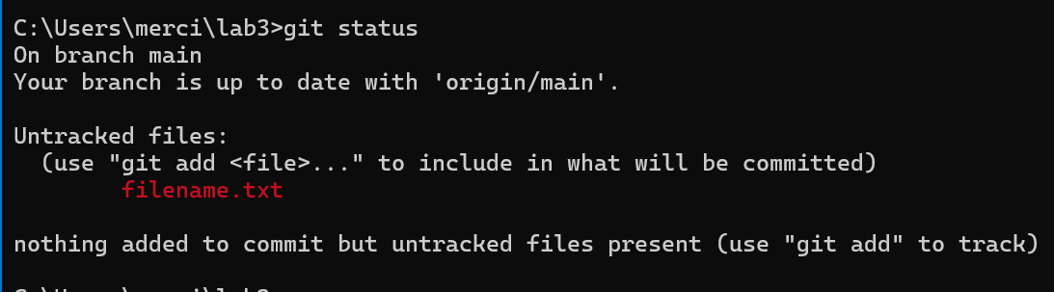

* 1. Stage the changes for commit

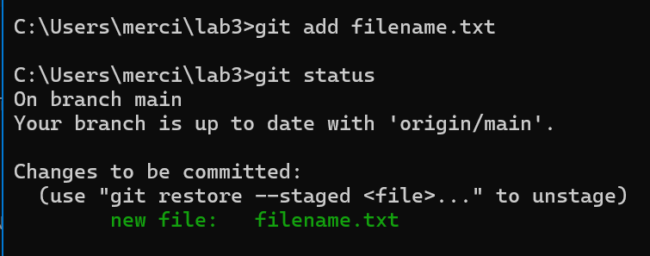

* 1. Commit the changes with a descriptive message "Edited_example.txt"

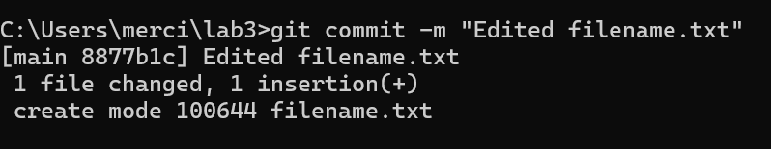

* 1. Create a new branch named "feature"
  2. Switch to the "feature" branch

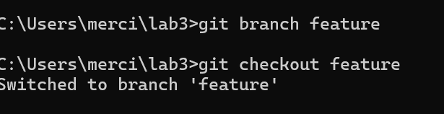

* 1. Pushing Changes to Bitbucket
* Pushing Changes to Bitbucket
  1. Add Repository URL in a variable
  2. Replace <repository_url> with the URL you copied from Bitbucket
  3. Push the "feature" branch to Bitbucket

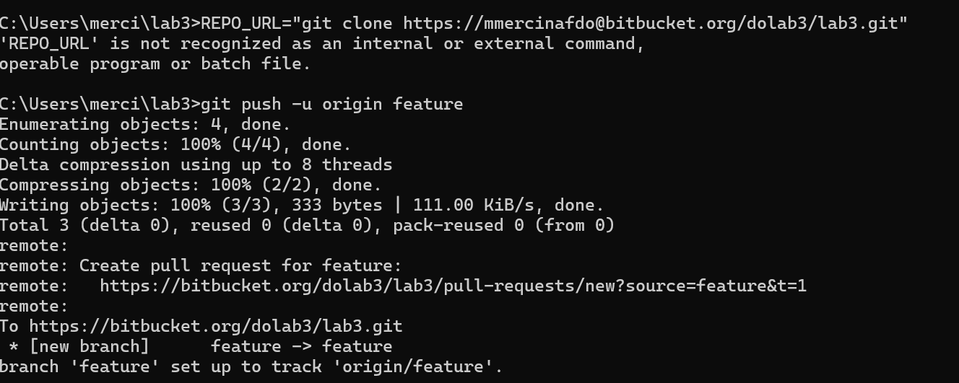

* 1. Check your Bitbucket repository to confirm that the new branch "feature" is available.

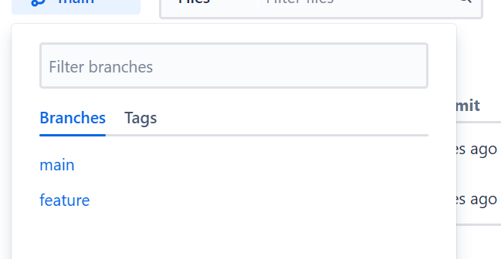

* Collaborating through Pull Requests
  1. Create a pull request on Bitbucket:
     1. Go to the repository on Bitbucket.
     2. Click on "Create pull request."
     3. Choose the source branch ("feature") and the target branch ("main" or
     4. "master").
     5. Review the changes and click "Create pull request."

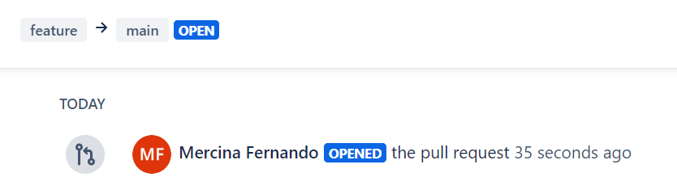

* 1. Review and merge the pull request:

1. Add a title and description for the pull request.
2. Assign reviewers if needed.
3. Once the pull request is approved, merge it into the target branch.

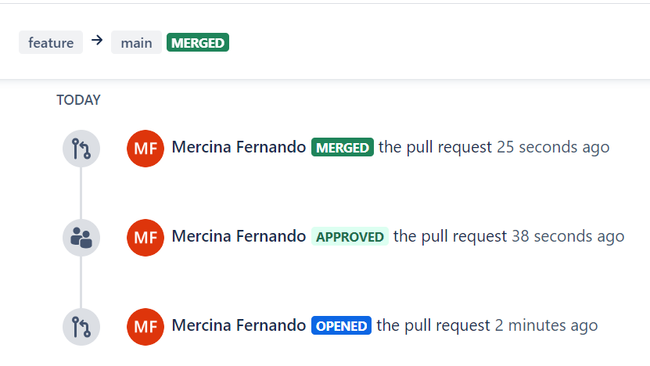

* Syncing Changes

1. After the pull request is merged, update your local repository

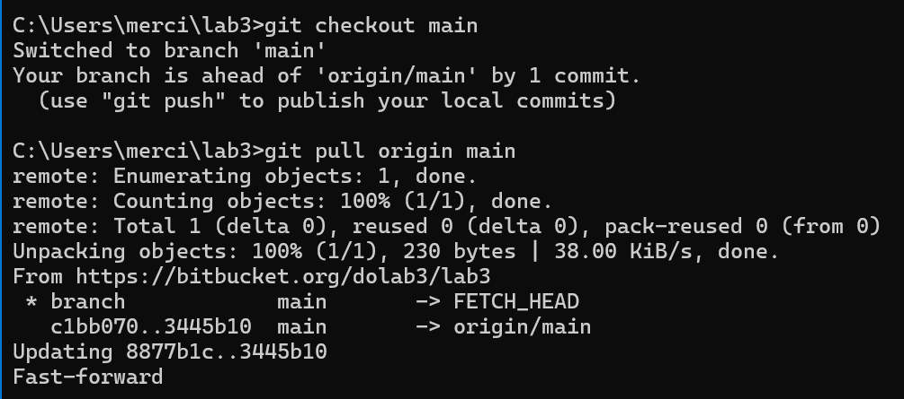

**Result:** The above procedure to implement Bitbucket operations using Git has been successfully executed.

|  |  |
| --- | --- |
| **Ex. No: 4** | **Advanced Commands** |
| **08-08-24** |

**AIM:** Implement the git advanced commands

**PROCEDURE:**

Rebase:

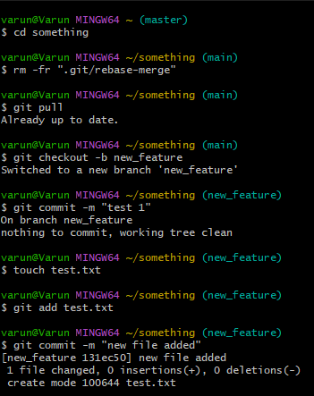

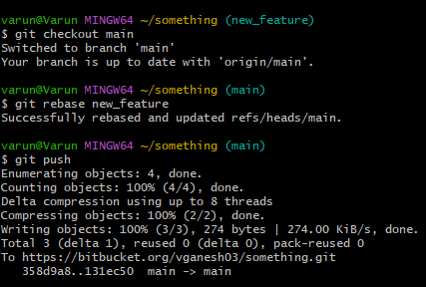

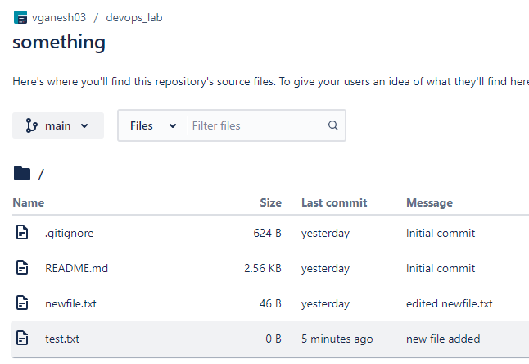

Stash:

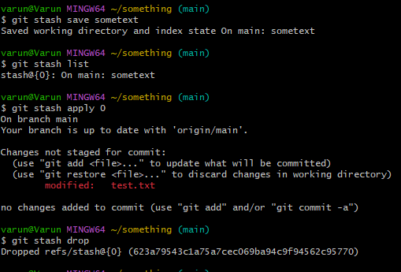

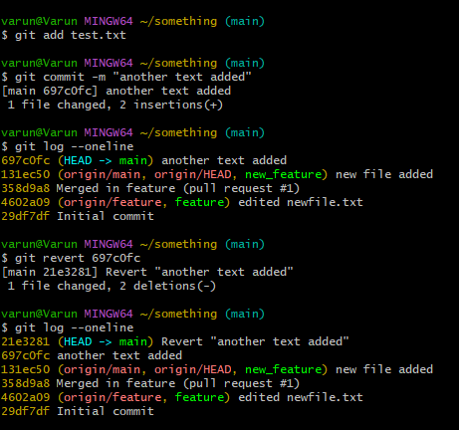Revert:

Reset:

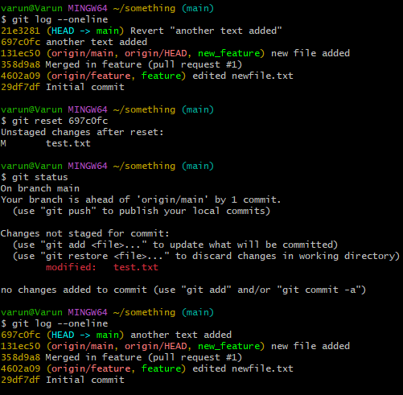

Cherry-Pick

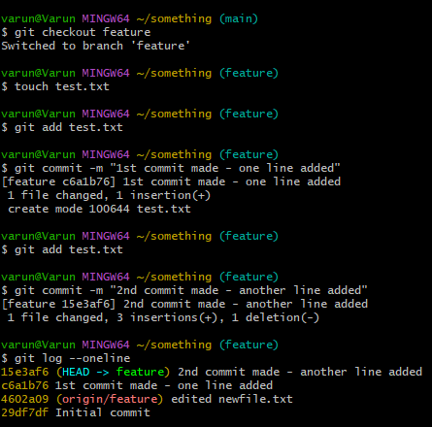

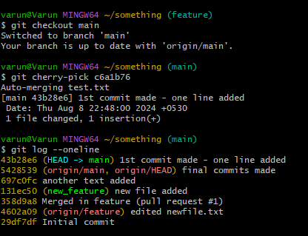

Sub Module:

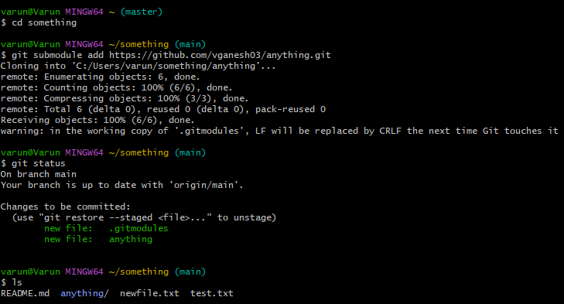

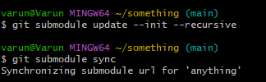

**RESULT:** Thus, the advanced git commands were implemented successfully.

|  |  |
| --- | --- |
| **Ex. No: 5** | **Maven POM Inheritance & Aggregation** |
| **28.08.2024** |

**Aim:** To implement Maven POM Inheritance and Aggregation.

**Procedure:**

Set Up the Parent POM

Create the Parent Project

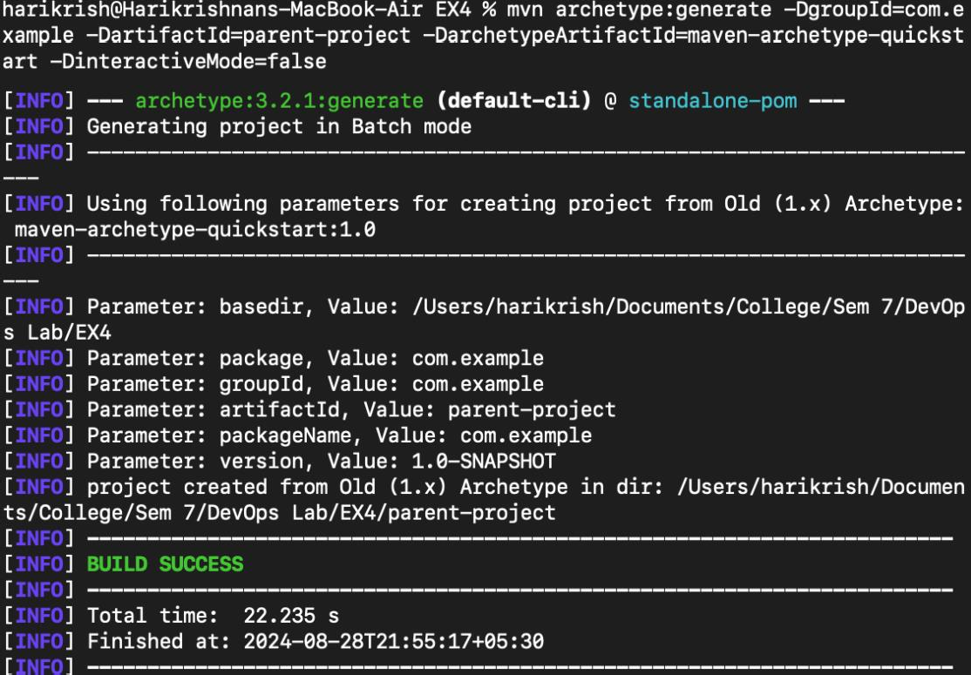

Modify the Parent pom.xml

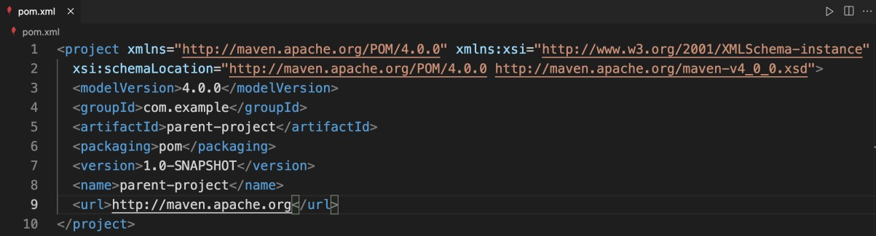

Updated pom.xml to act as a parent by adding the <packaging> element as pom and removing the <dependencies> section

Create Child Projects

Create Child Modules

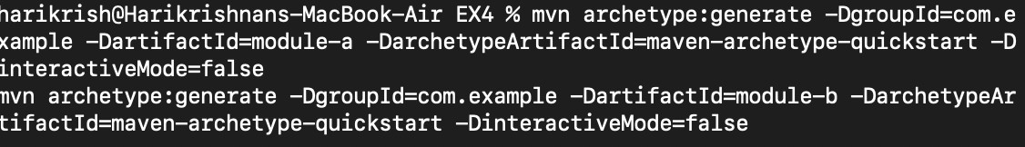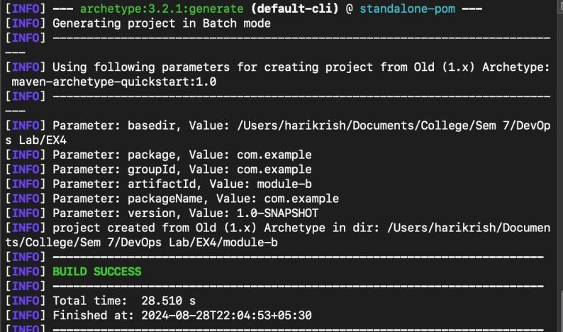

Add Child Modules to the Parent pom.xml

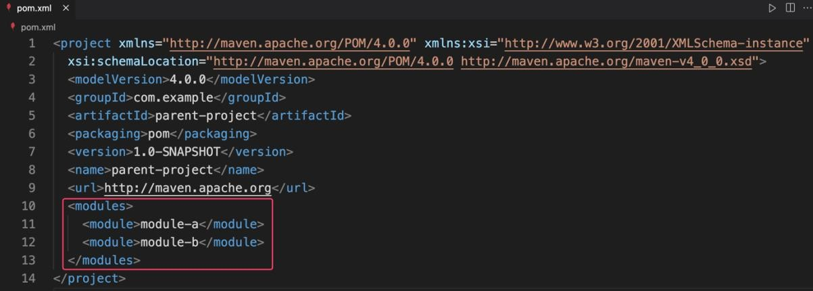

Configure Inheritance in Child pom.xml

Modify Child pom.xml Files

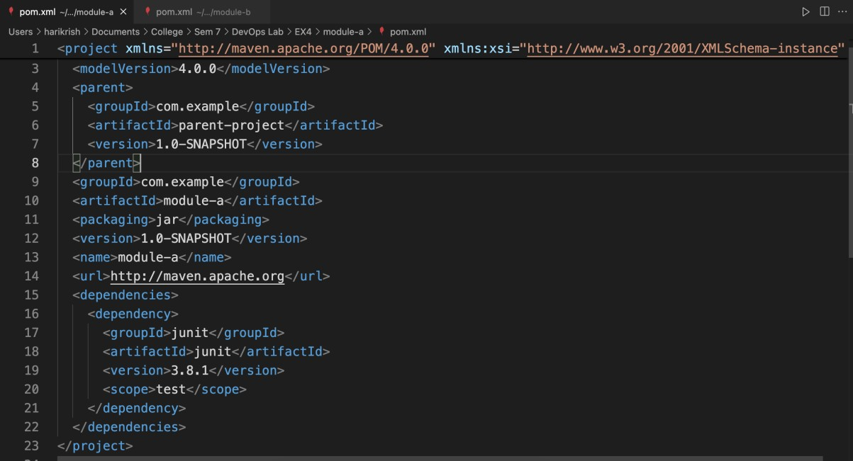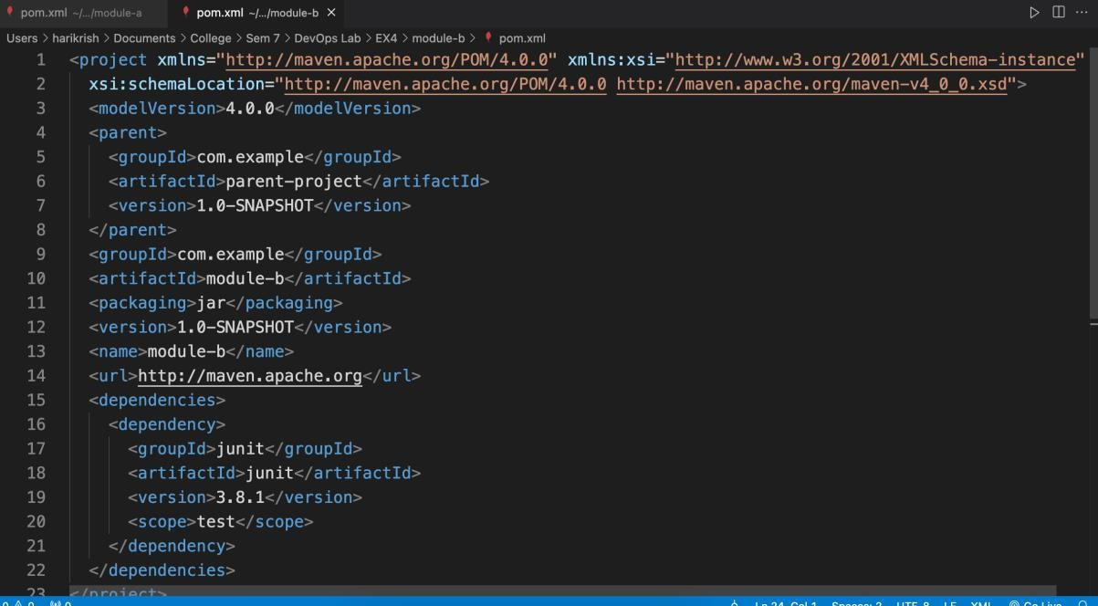

Add Common Dependencies and Properties in Parent pom.xml

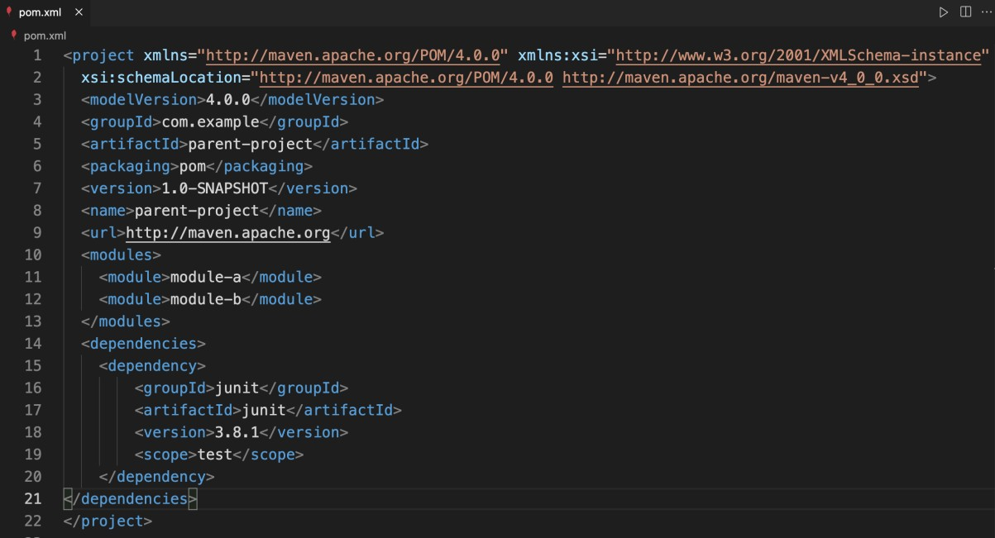

Build the Project

Build All Modules

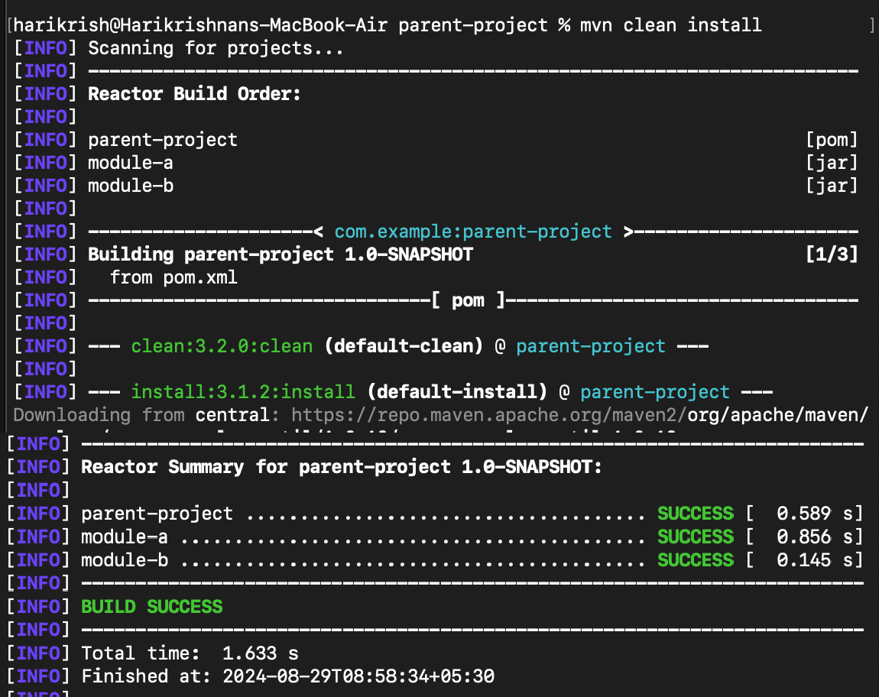

Build Individual Modules

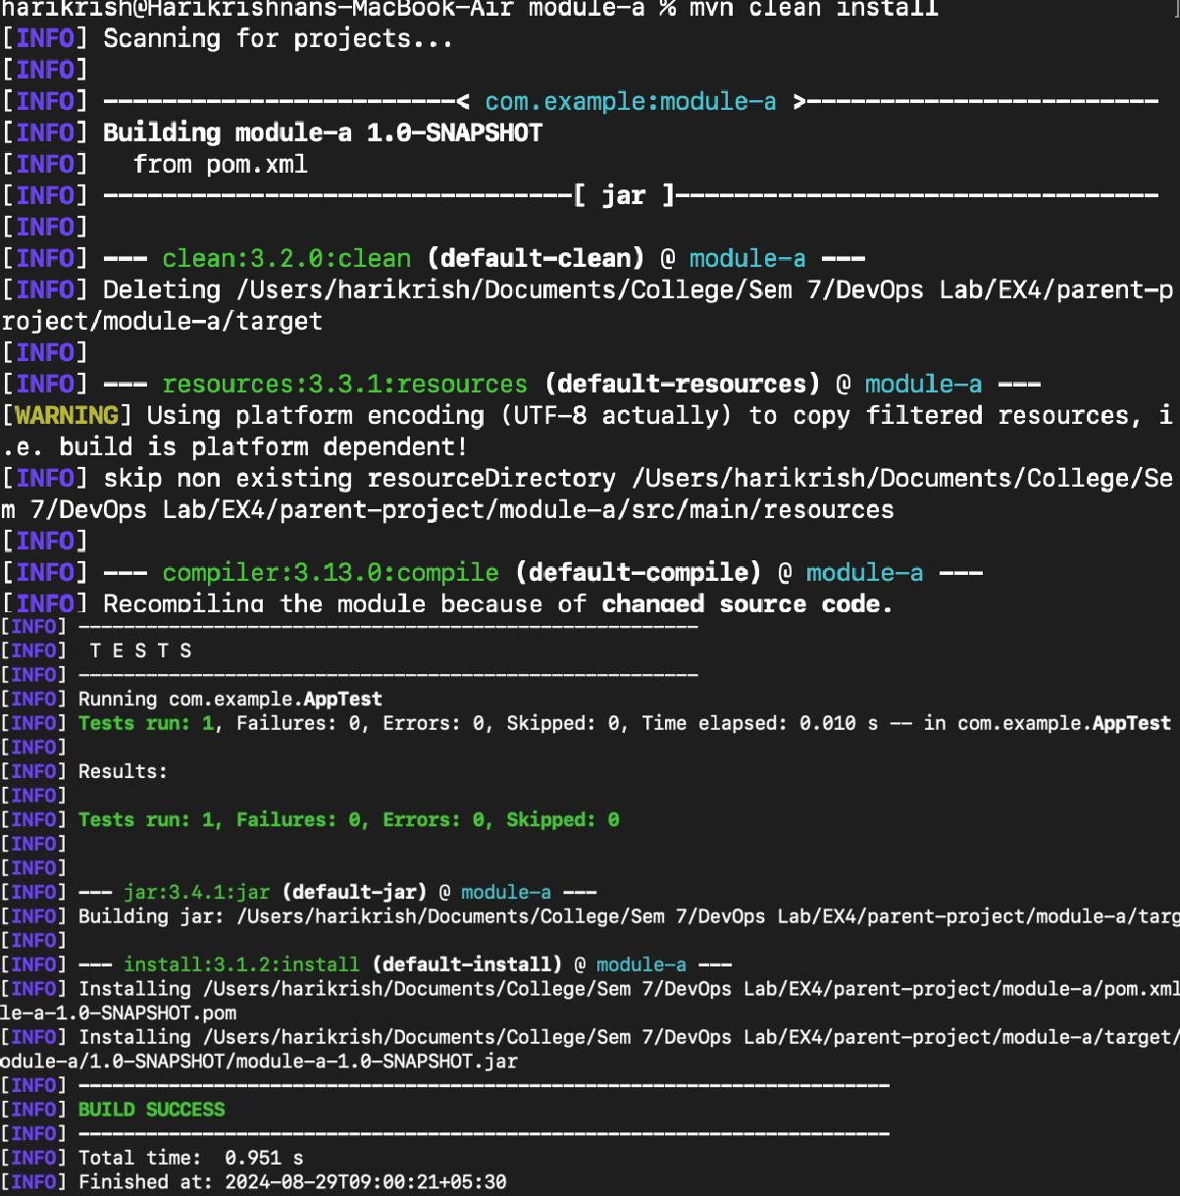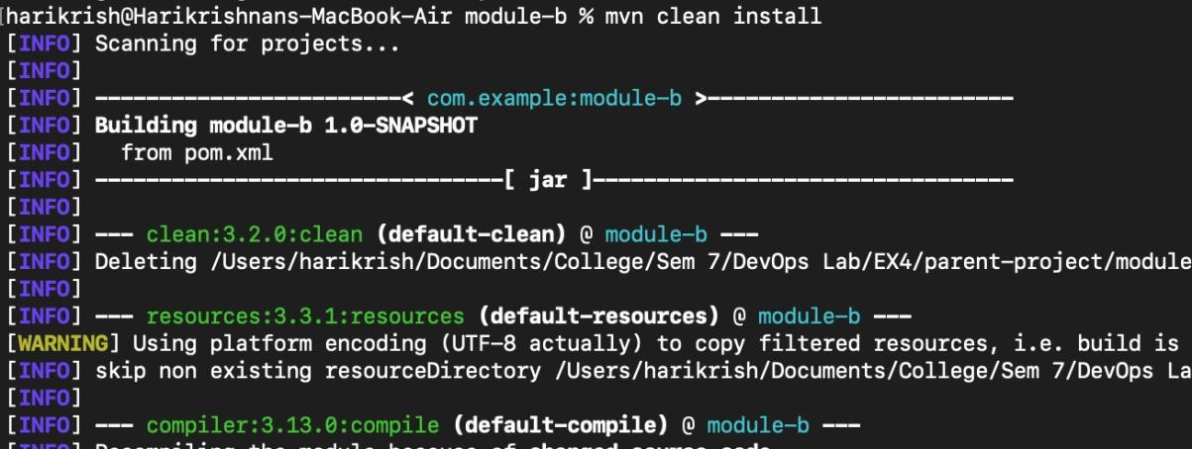

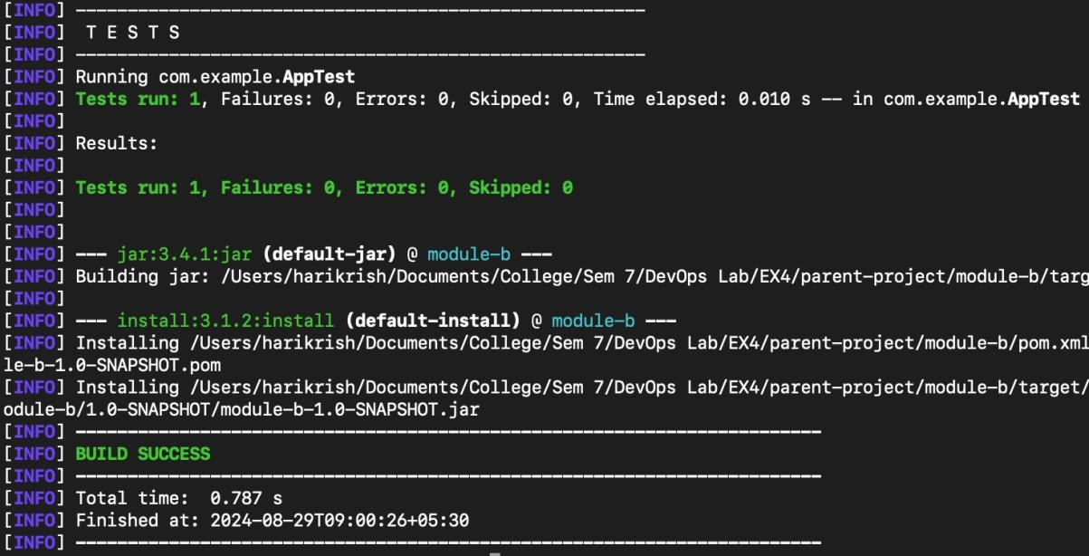

Verify Inheritance and Aggregation

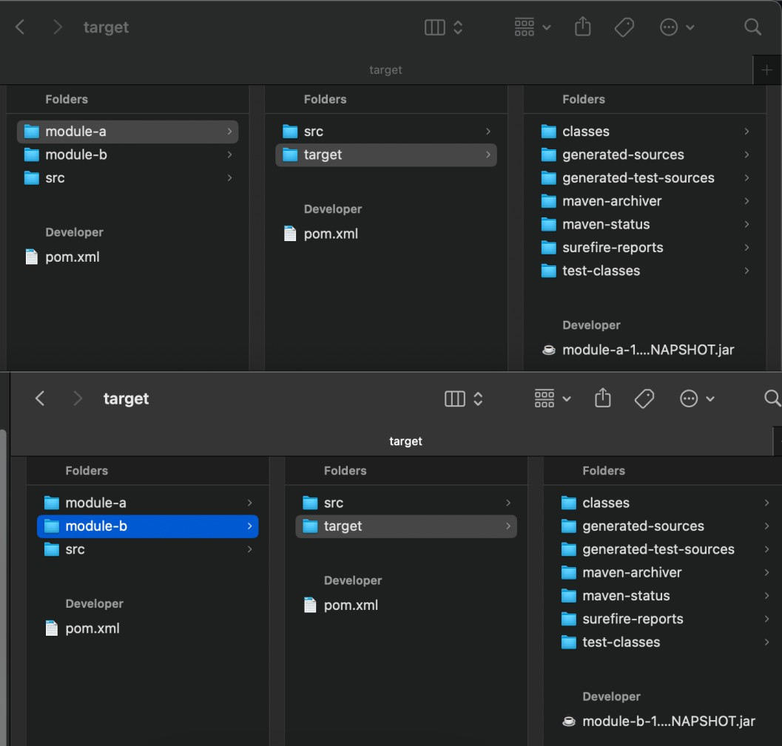

The ‘target’ directory in each module contains the generated JAR files. The parent settings, like shared dependencies are also reflected in the child modules.

**Result:** The above procedure to implement Maven POM Inheritance and Aggregation has been successfully executed.

|  |  |
| --- | --- |
| **Ex. No: 6** | **JAR Creation and Clean Lifecycle** |
| **28-08-24** |

**Aim:** To create JAR file and execute clean lifecycle.

**Procedure:**

Maven installation and java file creation:

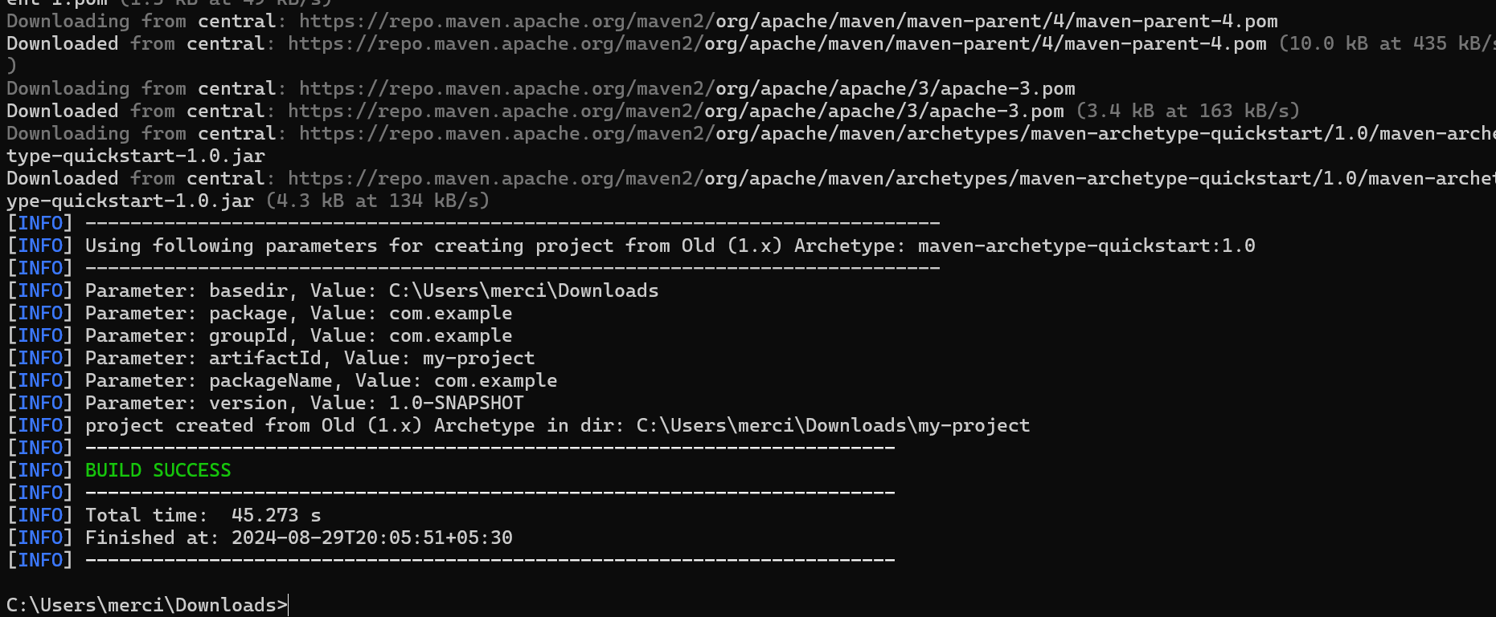

POM file format:

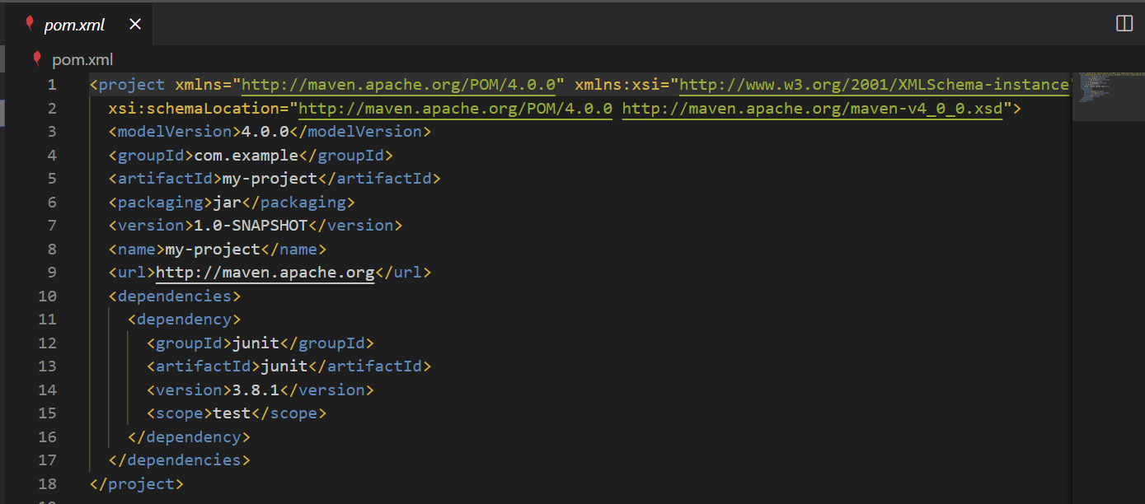

Clean lifecycle:

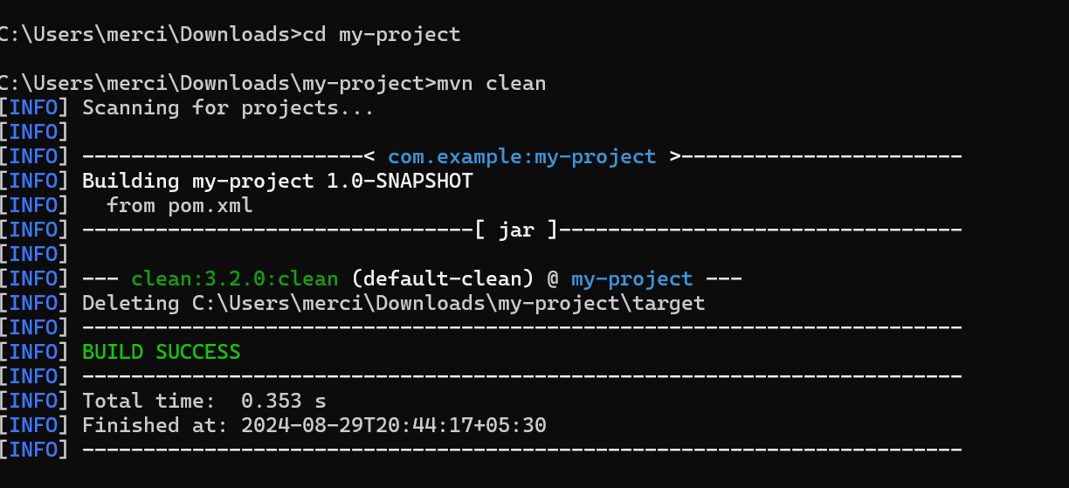

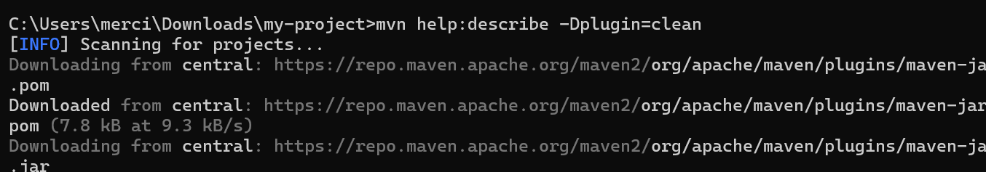

**Result:** The above procedure to create JAR file and execute clean lifecycle has been successfully executed.

|  |  |
| --- | --- |
| **Ex. No: 7** | **MAVEN** |
| **13-09-24** |

**AIM:** Solve the Questionnaire pertaining to Maven

**SOLUTIONS:**

Question 1: Customizing Maven Build Lifecycle

Answer: 1. The changes to be made in pom.xml are: In the <build> section of your pom.xml, we can configure the maven-surefire-plugin (used for running unit tests) and bind it to the integration-test phase.

Question 2: Adding External Dependencies and Managing Versions

Answer 2: To ensure consistent Spring Framework versions across a multi-module project, we can use the dependencyManagement section in the parent pom.xml. This ensures that all modules use the same version of dependencies.

Question 3: Skipping Tests During Build

Answer 3. “mvn clean install -DskipTests” this command skips all unit and integration testing.

Question 4: Managing Plugins for Code Coverage

Answer 4. To integrate JaCoCo for code coverage, and ensure the build fails if coverage is below 80%, we can modify the pom.xml to add the JaCoCo plugin and configure the rule to break the build.

Question 5: Managing Multi-Module Project Dependencies

Answer 5. In a multi-module project, if Module A depends on Module B, and we want Module A to automatically reflect changes from Module B, we need to structure the POMs to specify Module B as a dependency of Module A.

Question 6: Overriding a Dependency Version in a Child Module

Answer 6. If a child module needs a different version of a dependency (e.g., Hibernate) than what is defined in the parent POM, you can override the version in the child module’s pom.xml.

Question 7: Using Maven Properties to Manage Project Information

Answer 7. We can define properties within the <properties> tag of the pom.xml. We can then use these properties elsewhere in the pom.xml by referencing them with ${}

Question 8: Enforcing a Minimum Java Version for the Project

Answer 8. We can configure the maven-compiler-plugin in the pom.xml. both the source and target Java versions are set to 11, ensures the project only builds with Java 11 or higher.

Question 9: Customizing the Default Build Lifecycle

Answer 9. we can configure the Checkstyle plugin and bind it to the validate or compile phase. ensures that static code analysis is performed before the test phase in the build lifecycle.

Question 10: Skipping Specific Lifecycle Phases

Answer 10. “mvn verify -DskipTests”, This command will skip the unit tests (in the test phase) but continue with the integration-test and verify phases.

Question 11: Binding Goals to Custom Phases

Answer 11. we can bind it to a custom Maven profile. Profiles allow us to specify environment-specific configurations in Maven. Configure flyway plugin, bind it to custom phase, define profiles and run this command: “mvn clean install -Pstaging -Denv=staging”, ensures that Flyway runs only in the appropriate environments, and we can switch between environments using Maven profiles.

Question 12: Handling Failed Builds

Answer 12. We can define profiles in pom.xml, allow us to define different build configurations for different environments, such as development, testing, and production. Using this command: “mvn clean install -Pdevelopment”, to activate a profile.

Question 13: Using the Maven Site Lifecycle

Answer 13. configure the Maven Surefire plugin and bind it to the testing profile to ensure unit tests only run when the testing profile is active.

Question 14: Multi-Module Build with Independent Modules

Answer 14. add a custom goal, such as generating API documentation with Javadoc, we can bind the Javadoc plugin to a specific phase like package or install. So configure Javadoc plugin in pom.xml.

Question 15: Customizing the Clean Lifecycle

Answer 15: We can customize the build output directories (such as where compiled classes and resources are stored) using the <build> section of the pom.xml. allows us to organize our project’s artifacts (classes, resources) in custom directories, depending on our project structure or needs.

Question 16: Using Plugin Inheritance with Custom Execution Goals

Answer 16: Managing different versions of the same library, known as dependency version conflicts, is a common issue in Maven. By using <exclusions> tag, using dependency management, maven enforcer plugin, ensures that the project adheres to the specified versions and avoids using different versions of the same library.

**RESULT:** The above questionnaire was answered successfully.

|  |  |
| --- | --- |
| **Ex. No: 8** | **Jenkins and Webhooks** |
| **21-10-2024** |

**Aim:** To set up a CI/CD pipeline for a web development project using Jenkins, Git, and webhooks, without the need for a Jenkinsfile**.**

**Procedure:**

* Set Up the Web Application and Local HTTP Server using Apache or any other you comfortable with. Make sure it is configured right way, and its application is in running condition
* Set Up a Git Repository
* Install and Configure Jenkins
* Create a Jenkins Job using “Freestyle Project” type. Configure the job to use a webhook trigger. (Use "GitHub hook trigger for GITScm polling")
* Set Up the Jenkins Job (Using Execute Shell)
  + In the job configuration, go to the "Build" section.
  + Add a build step of type "Execute shell."
  + In the "Command" field, define the build and deployment steps using shell commands. For example:

# Checkout code from Git

# Build your web application (e.g., npm install, npm run build)

# Copy the build artefacts to the local HTTP server directory

rm -rf /var/www/html/webdirectory/*

cp -r * /var/www/html/webdirectory/

* Set Up a Webhook in Git Repository

1. In your Git repository (e.g., on GitHub), go to "Settings" and then "Webhooks."
2. Create a new webhook, and configure it to send a payload to the Jenkins webhook URL (usually http://jenkins-server/github-webhook/). (Make sure to set the content type to "application/json.")
3. OR use “GitHub hook trigger for GITScm polling?” Under Build Trigger

* Trigger the CI/CD Pipeline
  1. Push changes to your Git repository.
  2. The webhook should trigger the Jenkins job automatically, executing the build and deployment steps defined in the "Execute Shell" build step.
  3. Monitor the Jenkins job's progress in the Jenkins web interface.

* Verify the CI/CD Pipeline

Visit the URL of your local HTTP server to verify that the web application has been updated with the latest changes.

**Output:**

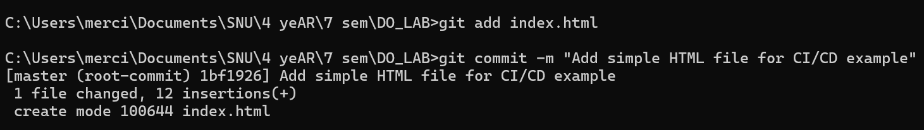

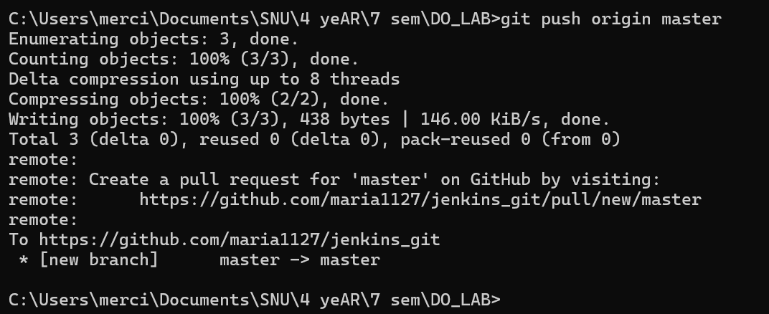

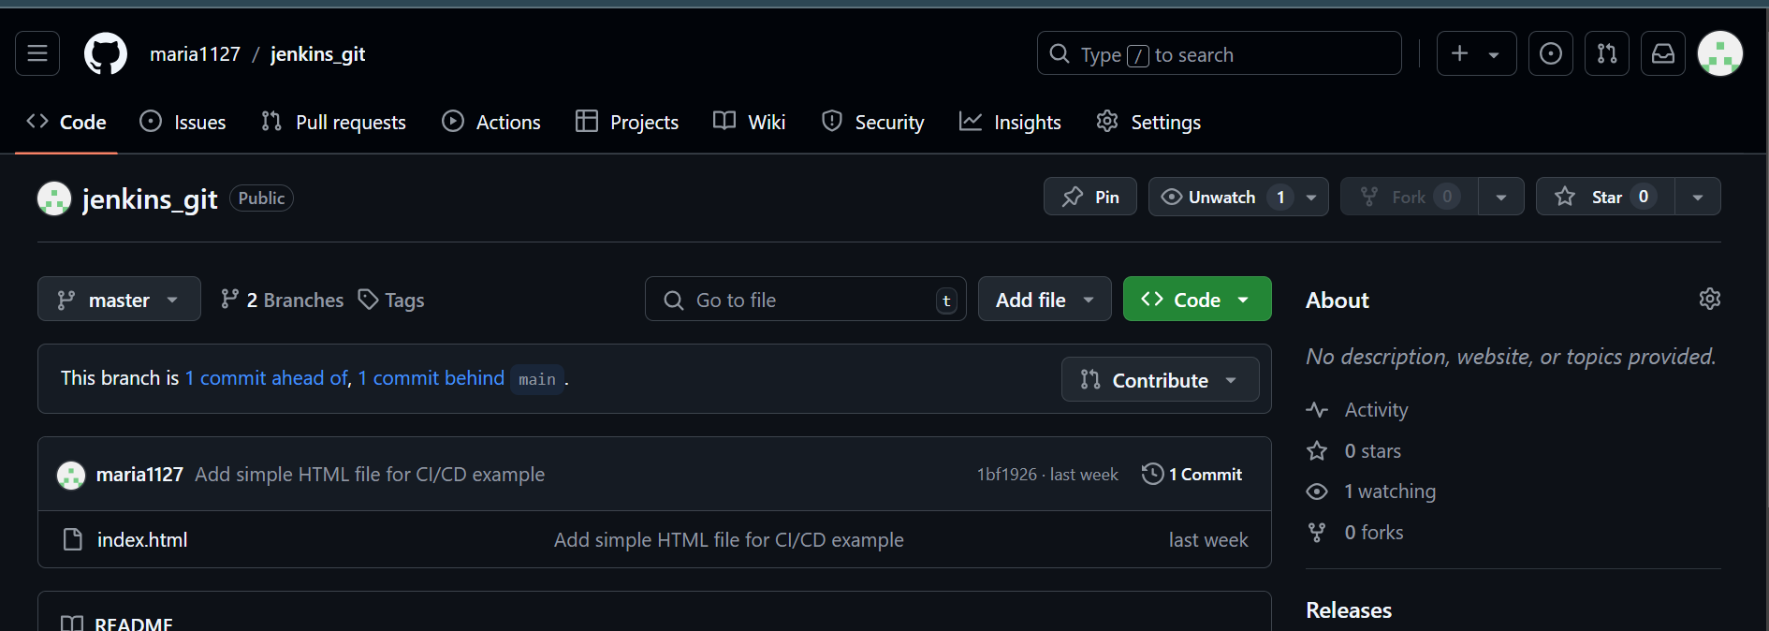

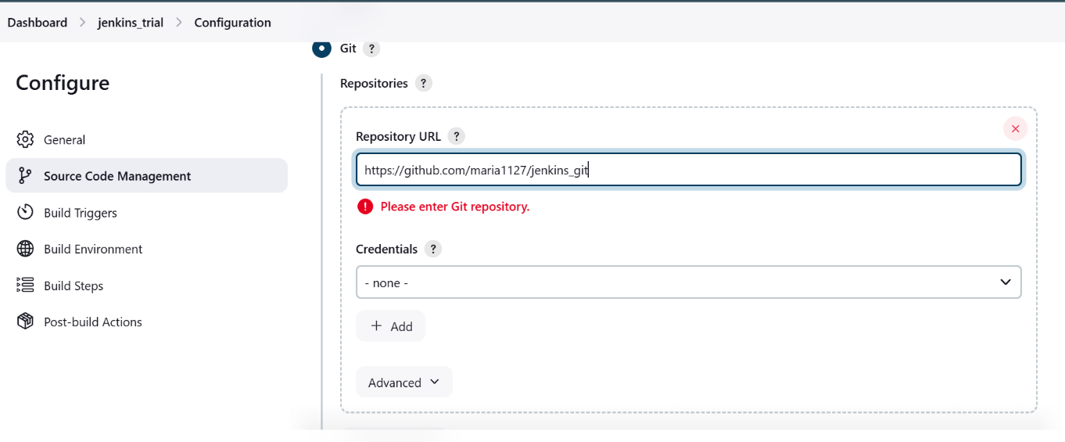

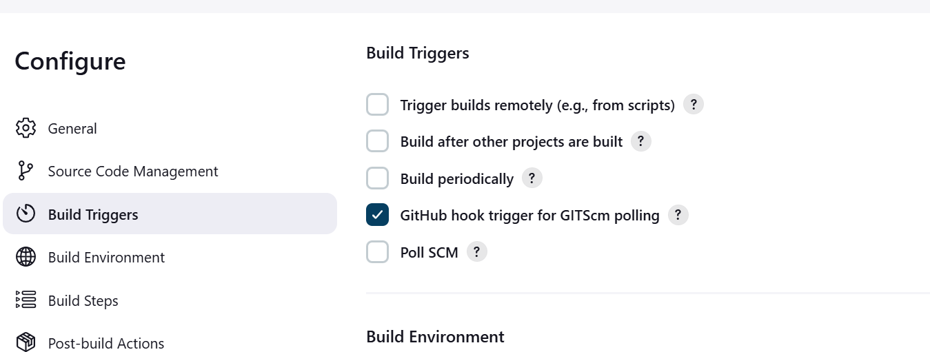

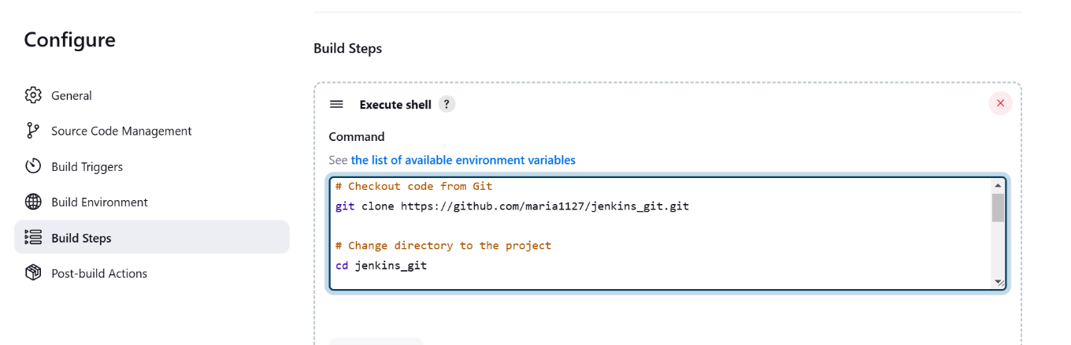

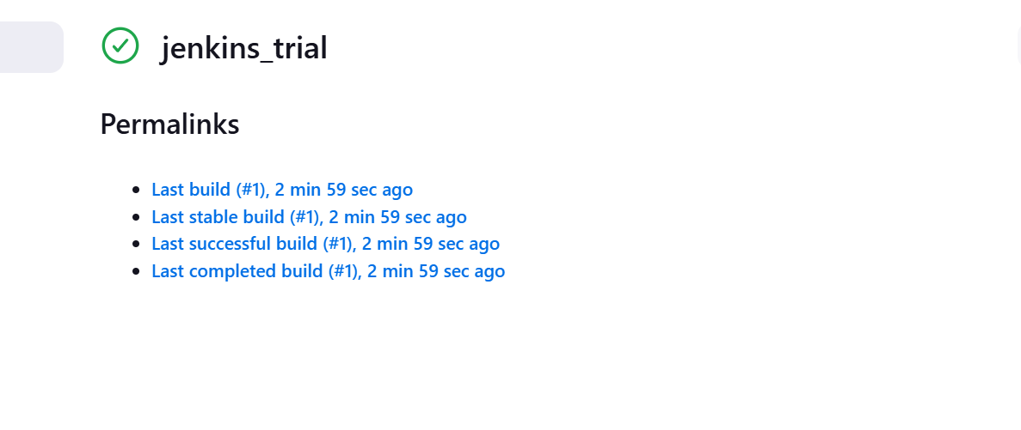

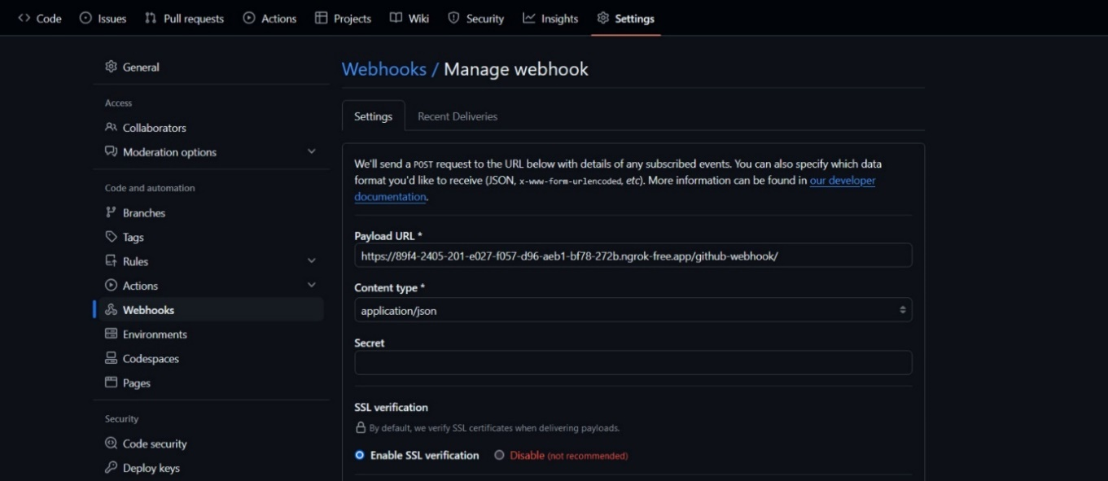

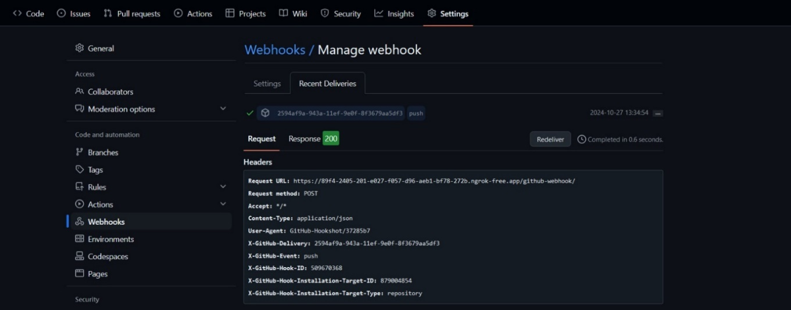

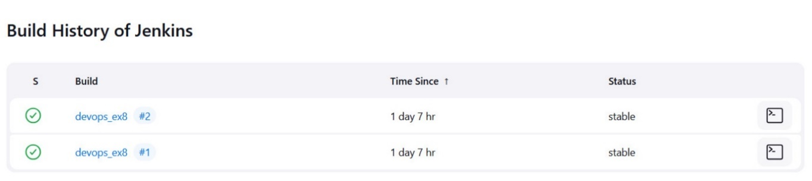

**Result:** The above procedure to set up a CI/CD pipeline for a web development project using Jenkins, Git, and webhooks, without the need for a Jenkinsfile has been successfully executed.

|  |  |
| --- | --- |
| **Ex. No: 9** | **Docker** |
| **23-10-2024** |

**Aim:** To explore Containerization and Application Deployment with Docker

**Procedure:**

1.Created a html page and initialized a docker file.  


HTML page:

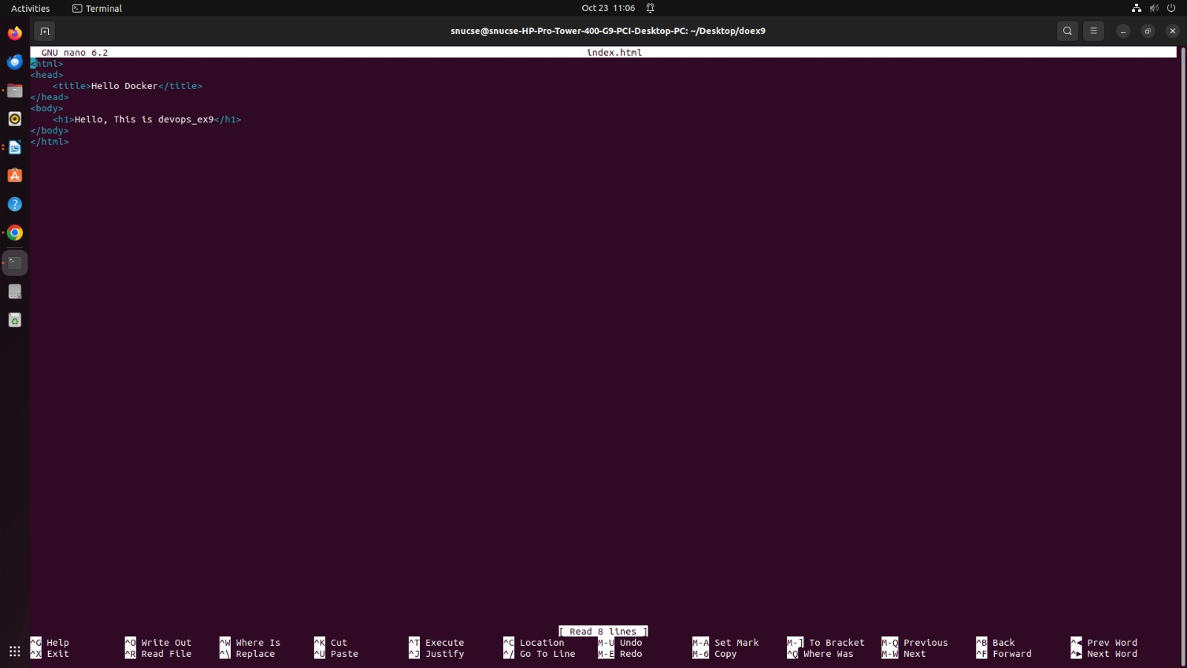

docker file:

# Use an official Apache HTTP server image as the base

FROM httpd:2.4

# Copy the index.html file to the Apache document root

COPY index.html /usr/local/apache2/htdocs/

2.Docker image is built.

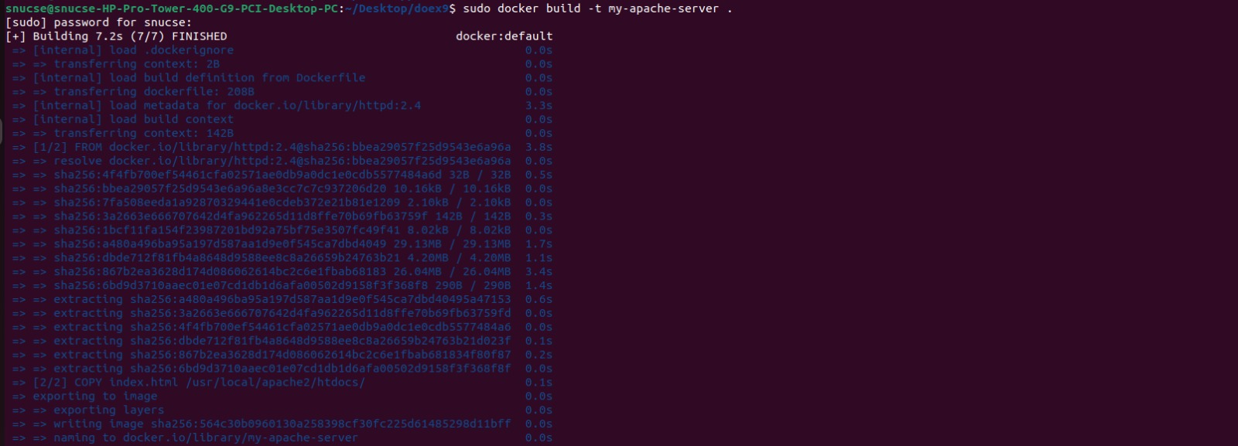

3.List of docker images



4.Running the docker container



5.Status of docker images:



6.Stoppigng the running container:



7.Removing the container:

 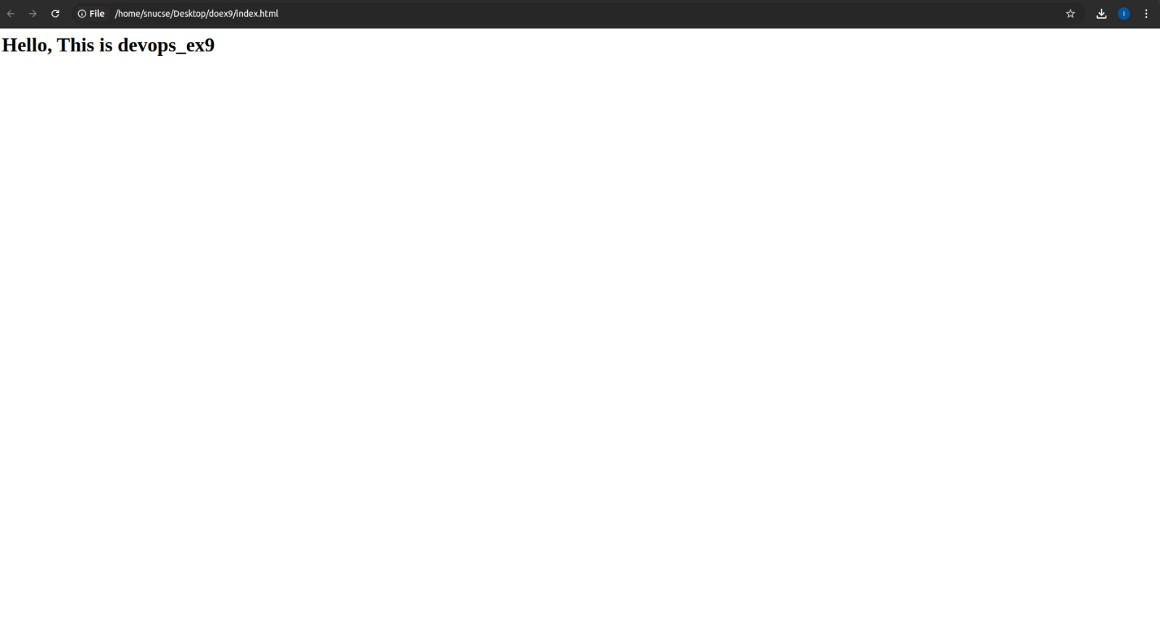

.

**Result**: The above procedure to explore Containerization and Application Deployment with Dockerhas been successfully executed.

|  |  |
| --- | --- |
| **Ex. No: 10** | **Jenkins and Docker** |
| **24-10-2024** |

**Aim:** To apply CI/CD Principles to Web Development Using Jenkins, Git, using

Docker Containers.

**Procedure:**

Step 1: Set Up the Web Application and Git Repository

Create a simple web application or use an existing one. Ensure it can be

hosted in a Docker container.

Initialise a Git repository for your web application and push it to GitHub.

Step 2: Install and Configure Jenkins

Install Jenkins on your computer or server following the instructions for your operating system (https://www.jenkins.io/download/).

Open Jenkins in your web browser (usually at http://localhost:8080) and

complete the initial setup, including setting up an admin user and installing

necessary plugins.

Configure Jenkins to work with Git by setting up Git credentials in the Jenkins

Credential Manager.

Step 3: Create a Jenkins Job

* Create a new Jenkins job using the "Freestyle project" type.
* In the job configuration, specify a name for your job and choose "This project is parameterized."
* Add a "String Parameter" named GIT_REPO_URL and set its default value to your Git repository URL.
* Set Branches to build -> Branch Specifier to the working Git branch (ex*/master)
* In the job configuration, go to the "Build Triggers" section and select the
* "GitHub hook trigger for GITScm polling" option. This enables Jenkins to
* listen for GitHub webhook triggers.

Step 4: Configure Build Steps

In the job configuration, go to the "Build" section.

Add build steps to execute Docker commands for building and deploying the

containerized web application. Use the following commands:

# Remove the existing container if it exists

docker rm --force container1

# Build a new Docker image

docker build -t nginx-image1 .

# Run the Docker container

docker run -d -p 8081:80 --name=container1 nginx-image1

These commands remove the existing container (if any), build a Docker

image named "nginx-image1," and run a Docker container named

"container1" on port 8081.

Step 5: Set Up a GitHub Webhook

In your GitHub repository, navigate to "Settings" and then "Webhooks."

[Create a new webhook, and configure it to send a payload to the Jenkins

webhook URL (usually http://jenkins-server/github-webhook/). Set the content

type to "application/json."

Step 6: Trigger the CI/CD Pipeline

Push changes to your GitHub repository. The webhook will trigger the Jenkins

job automatically, executing the build and deployment steps defined in the job

configuration.

Monitor the Jenkins job's progress in the Jenkins web interface.

Step 7: Verify the Deployment

Access your web application by opening a web browser and navigating to

http://localhost:8081 (or the appropriate URL if hosted elsewhere).

**Output:**

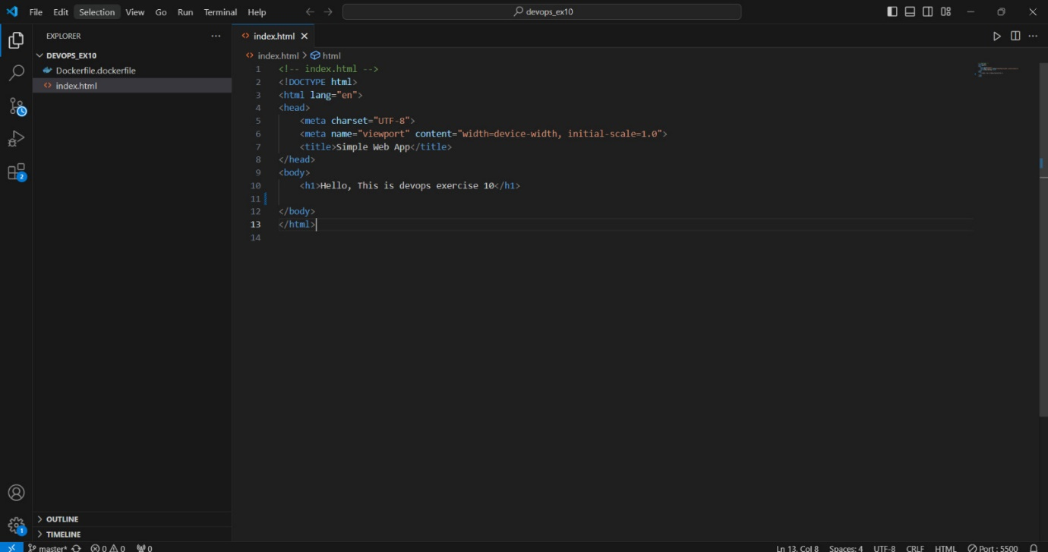

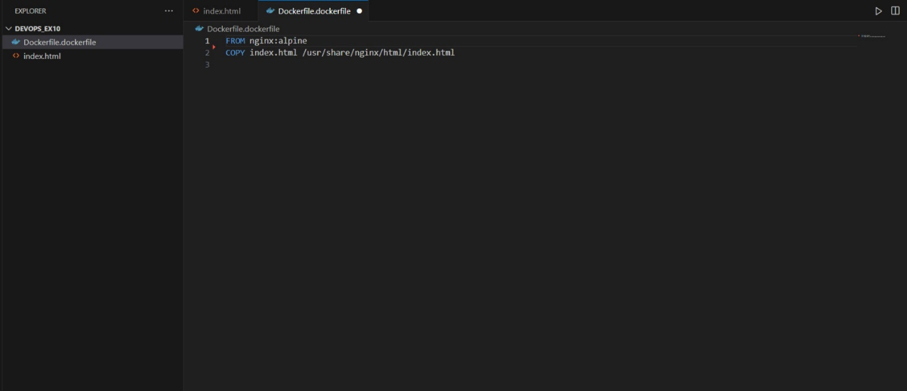

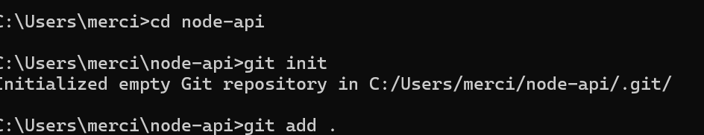



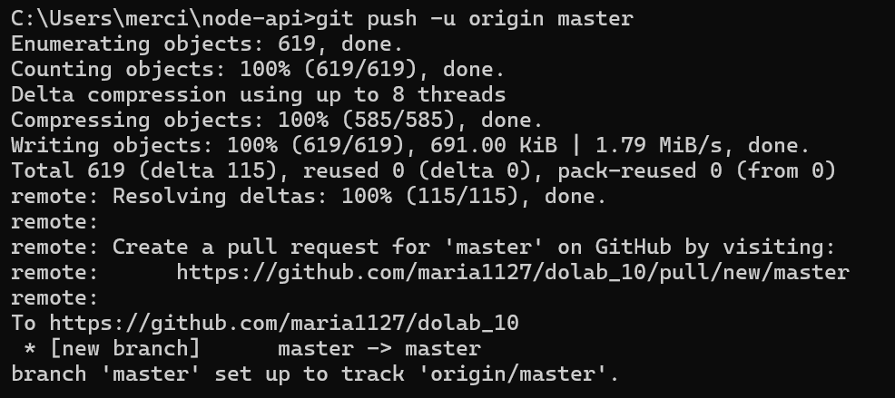

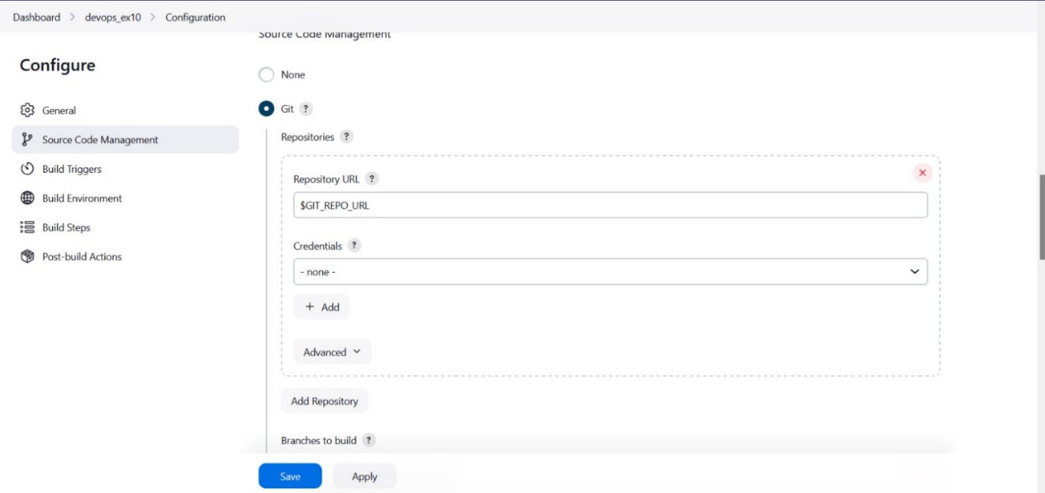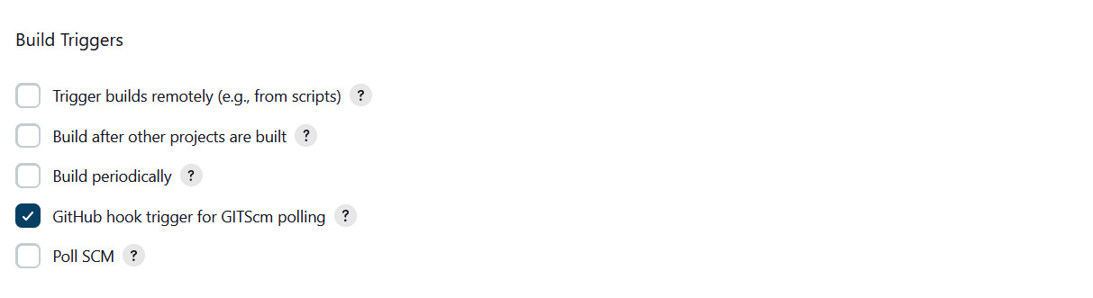

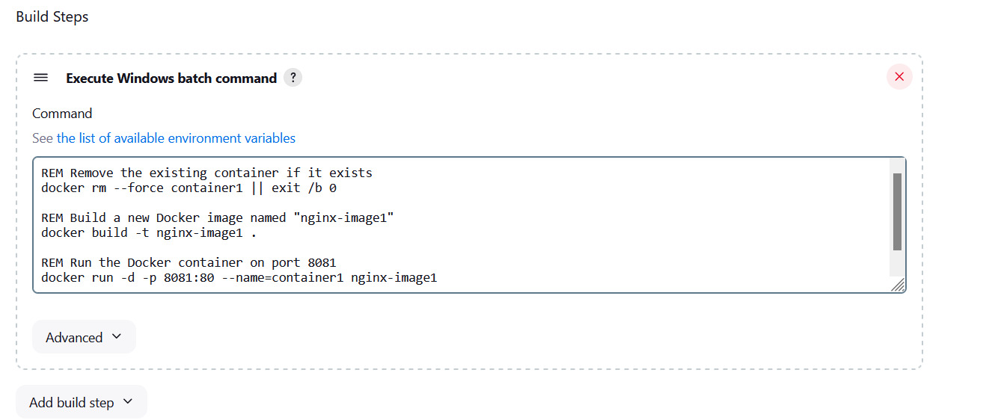

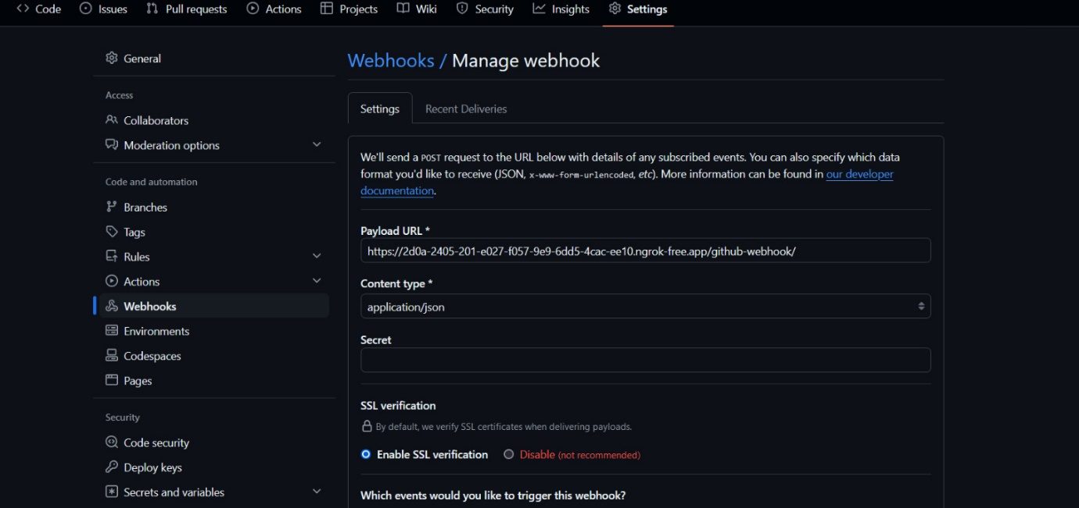

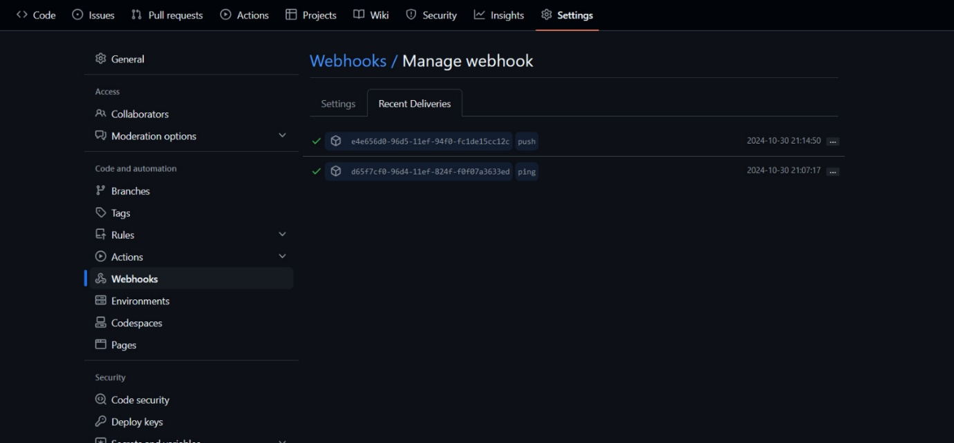

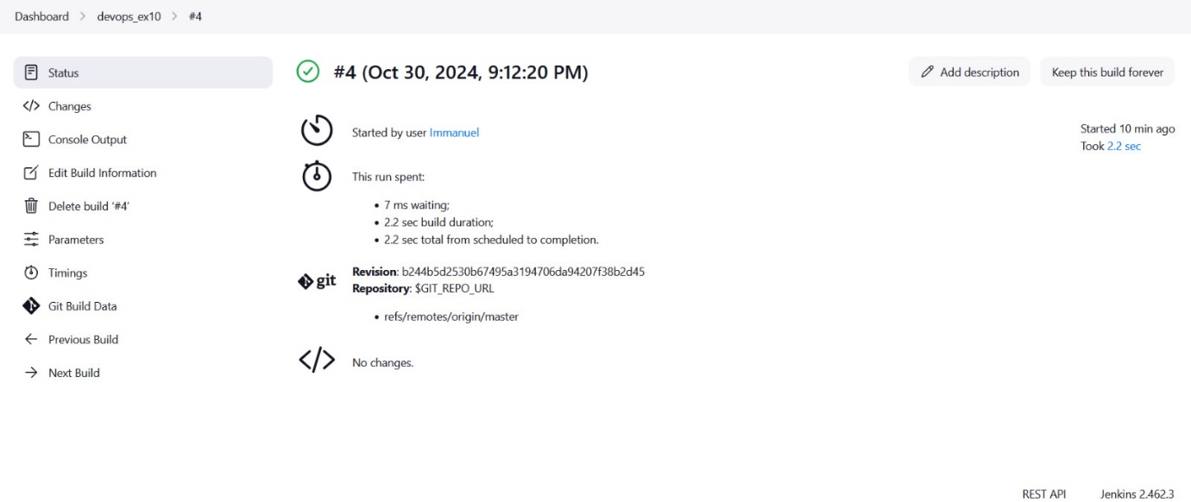

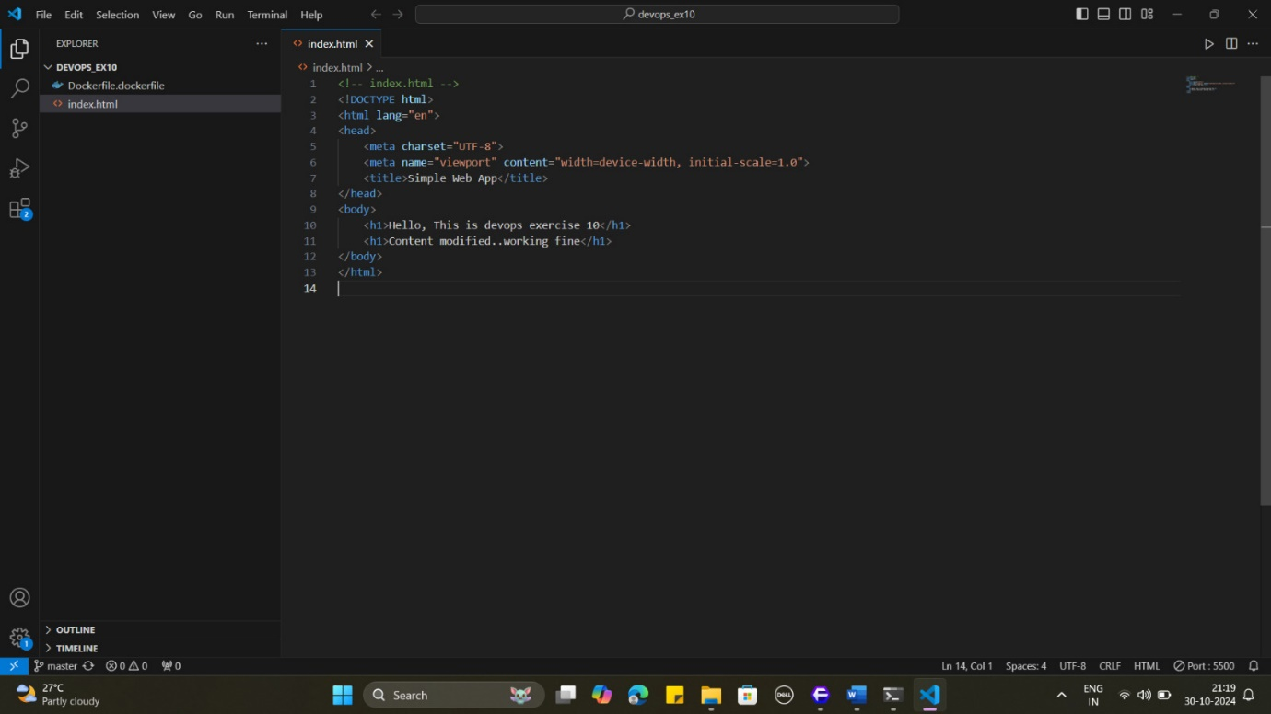

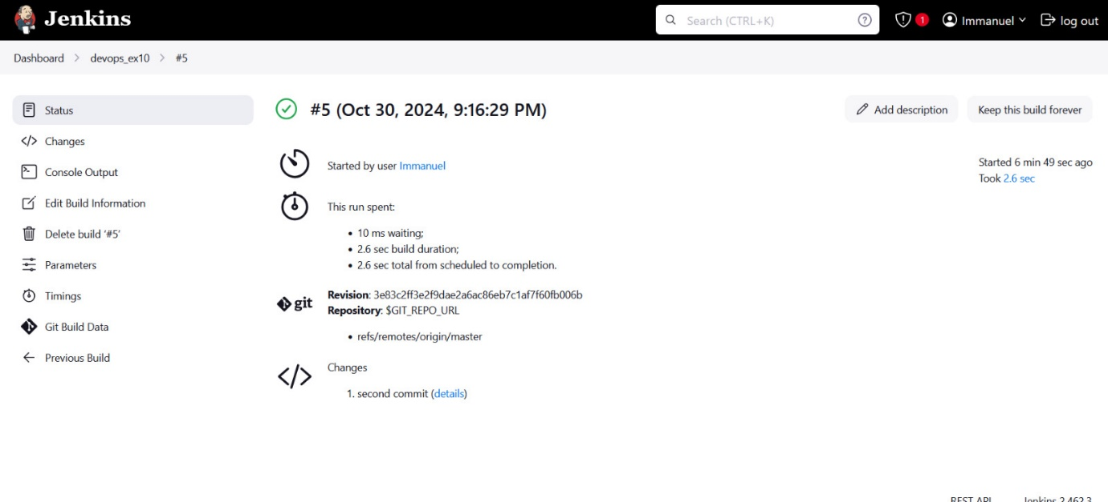

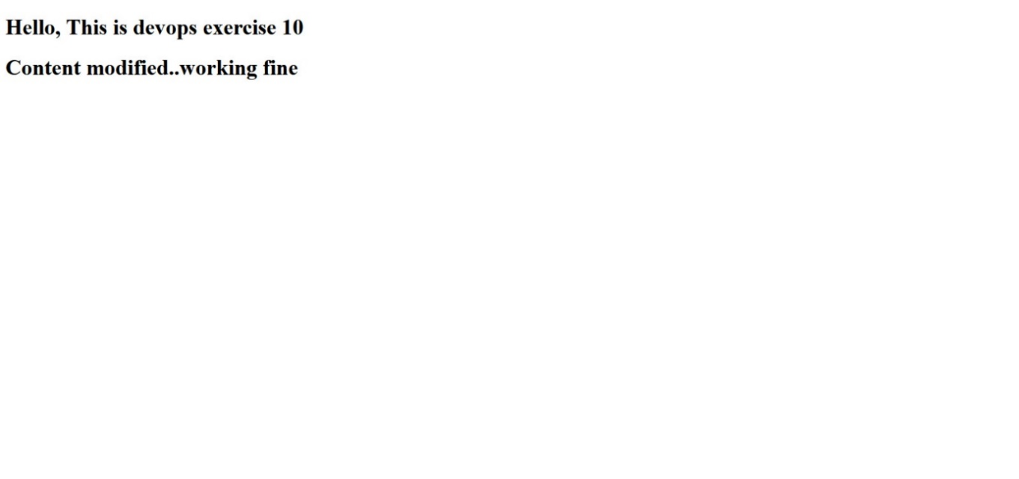

**Result:** The above procedure to apply CI/CD Principles to Web Development Using Jenkins, Git, using Docker Containers has been successfully executed.

|  |  |
| --- | --- |
| **Ex. No: 11** | **NodeJS** |
| **24-10-2024** |

**Aim:** To apply CI/CD Principles for NodeJS application Using Jenkins, Git, using Docker Containers

**Procedure:**

#### Step 1: Set up the Node.js Application

1. Initialize a Node.js Project
2. Install Express
3. Create index.js: This will contain your API logic.
4. Test the API by running:

Visit http://localhost:3000/status to check if it’s returning the correct JSON response.

#### Step 2: Containerize the Application Using Docker

1. Create a Dockerfile in the project directory:
2. Build the Docker Image:
3. Run the Docker Container to test locally:

Step 3: Push the Code to a Git Repository

1. Initialize a Git repository and push your code to a remote repository (e.g., GitHub):

Step 4: Set Up Jenkins for CI/CD

1. Install Jenkins: Make sure Jenkins is installed and accessible. You can run it locally or deploy it on a server.
2. Create a New Pipeline Job in Jenkins:
   * Go to New Item > Pipeline and name your project.
3. Configure the Pipeline Script:
   * In the Pipeline section, use the following script (or Jenkinsfile in your repository):

Step 5: Test the CI/CD Pipeline

1. Run the Pipeline: Start the Jenkins job. The steps in the pipeline will be executed in sequence:
   * Clone the repository.
   * Build the Docker image.
   * Run tests inside the Docker container.
   * Push the Docker image to DockerHub.
   * Deploy the image to your server.
2. Verify the Deployment: Check if the application is running on your server by visiting <http://your-server-ip:3000/status>.

**Output:**

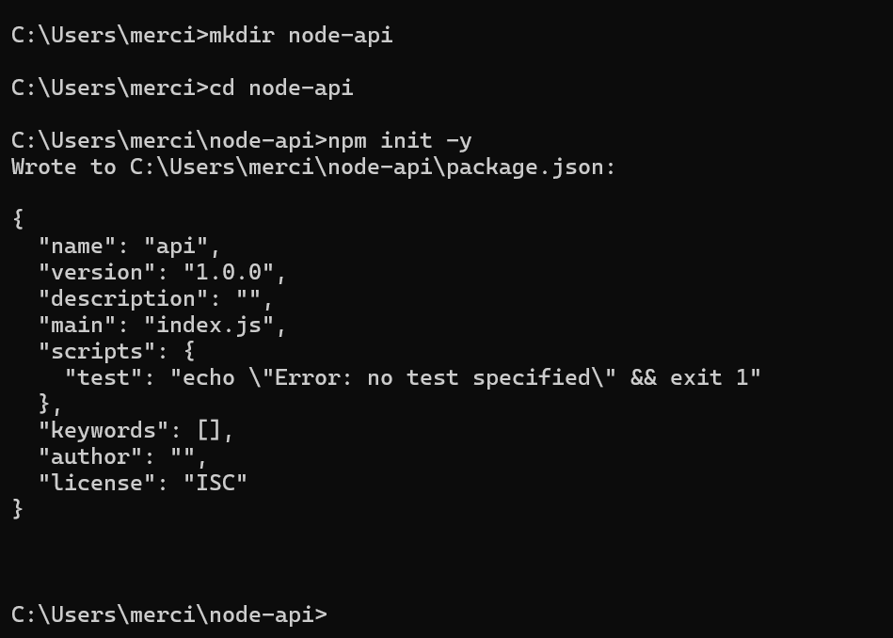

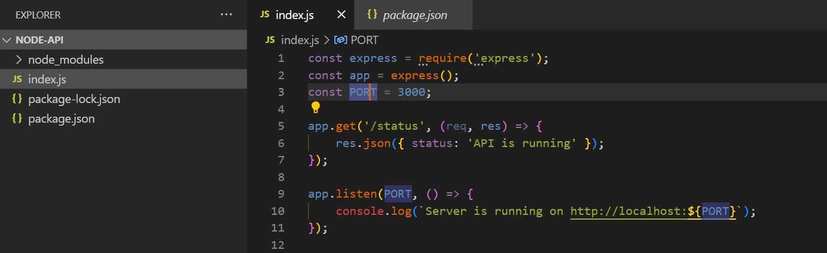

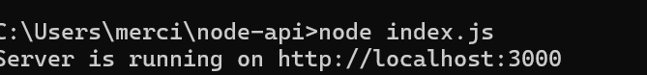

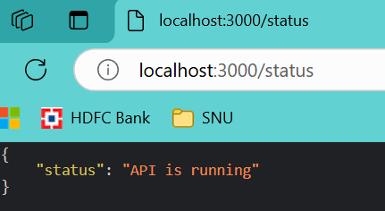

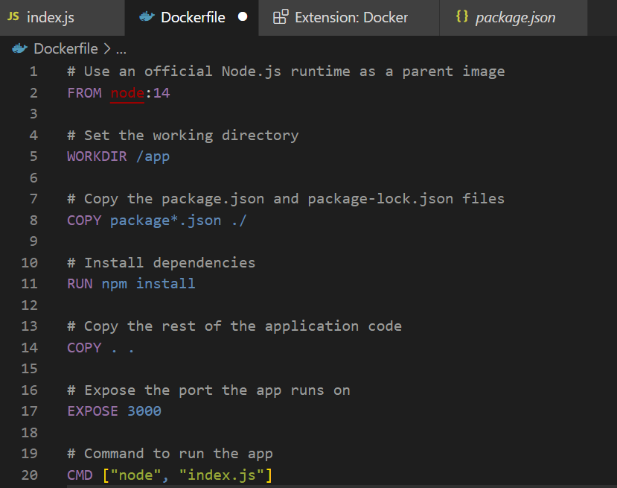

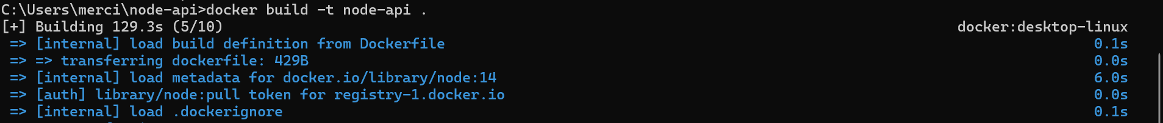

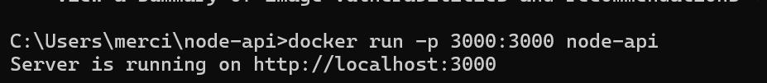







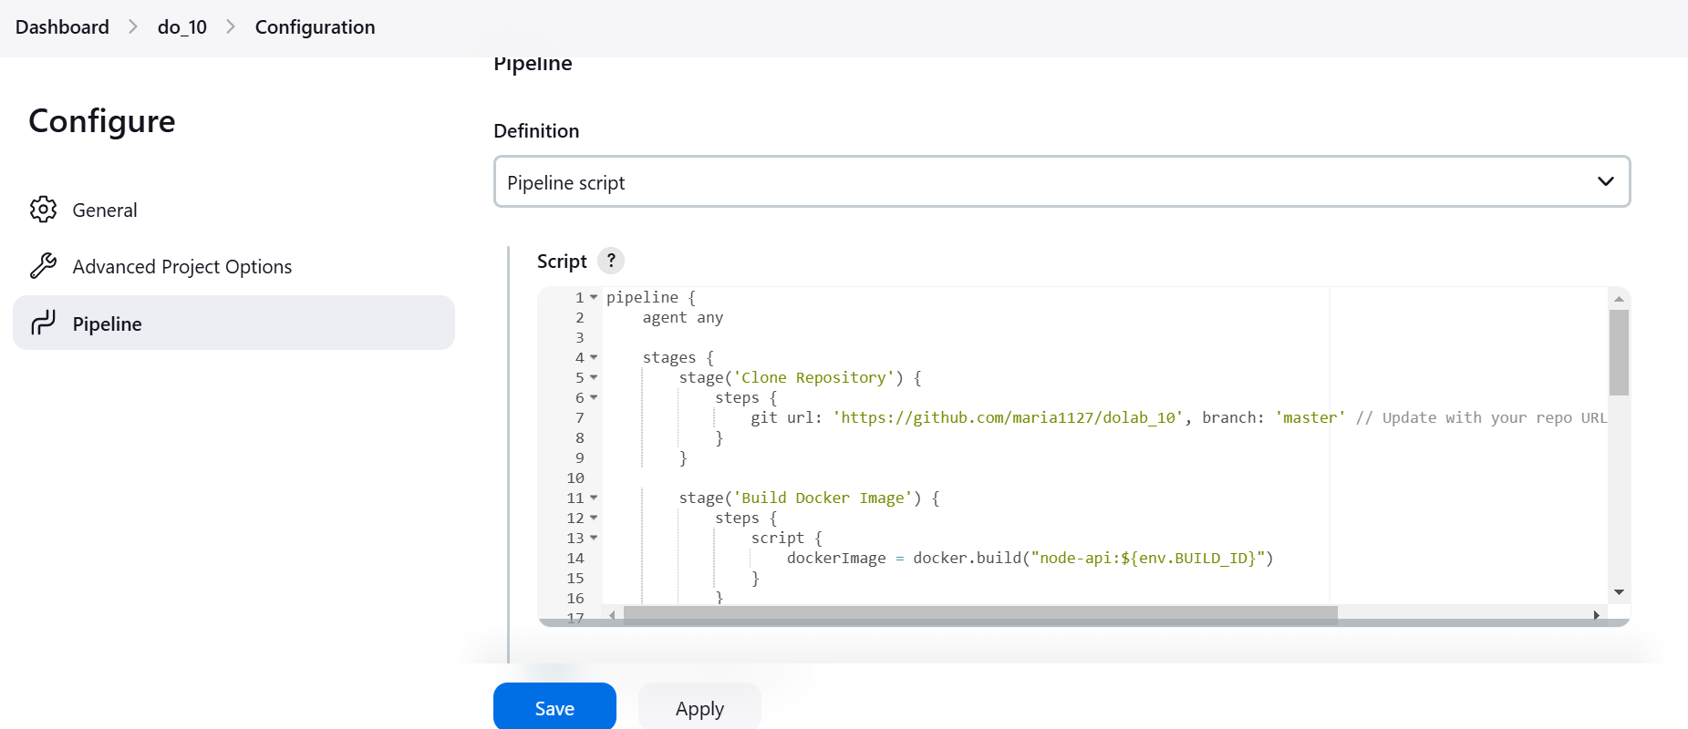

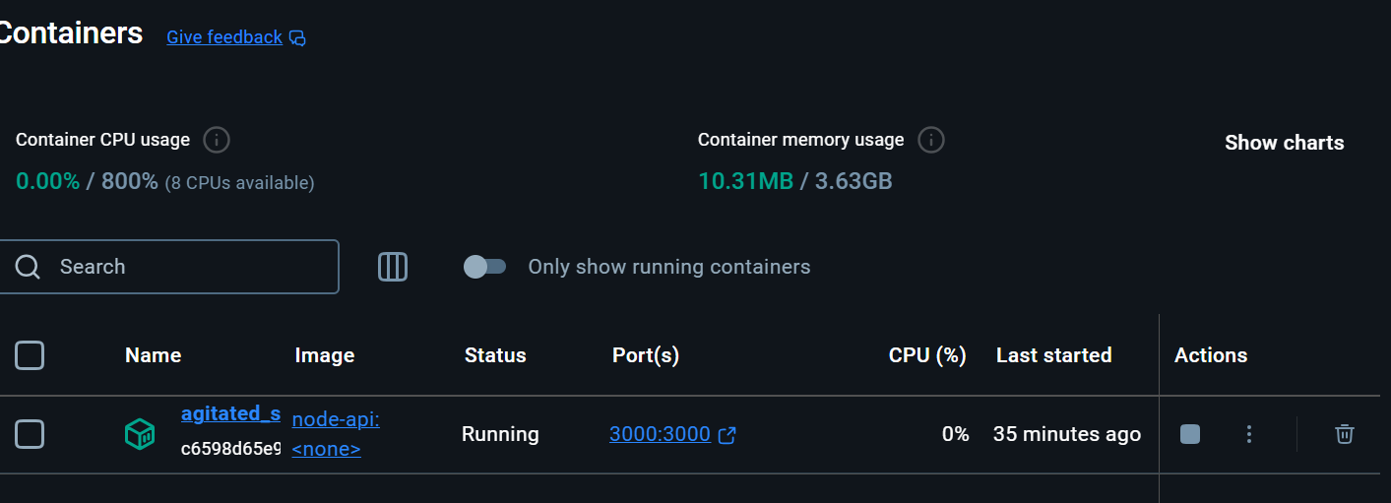

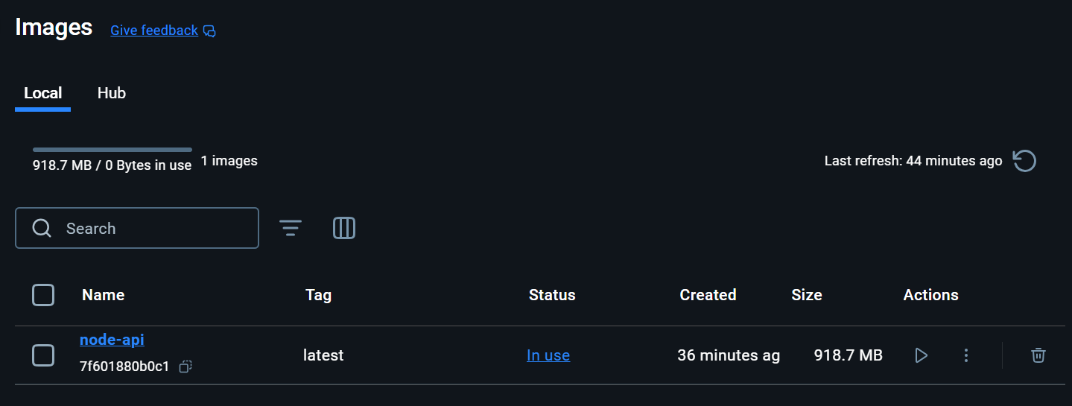

**Result:** The above procedure to apply CI/CD Principles for NodeJS application Using Jenkins, Git, using Docker Containershas been successfully executed.

|  |  |
| --- | --- |
| **Ex. No: 12** | **Blue-Green Deployment** |
| **24-10-2024** |

**AIM:** Implement a Blue-Green Deployment strategy for a Node.js application.

**PROCEDURE:**

1. Setup webapp in express.js and containerize it.
2. Create a dockerfile
3. Create github repository and commit/push
4. Create Jenkins job
5. Select pipeline, and add the following jenkinsfile groovy script:  
   pipeline {

agent any

environment {

DOCKER_HUB_REPO = 'vganesh03/hello-world-app'

BLUE_ENV = 'blue_env'

GREEN_ENV = 'green_env'

}

stages {

stage('Build') {

steps {

script {

docker.build("${DOCKER_HUB_REPO}:${env.BUILD_ID}")

}

}

}

stage('Deploy to Blue') {

steps {

script {

def blueContainer = docker.image("${DOCKER_HUB_REPO}:${env.BUILD_ID}")

// Use double quotes to interpolate the variable

blueContainer.run("-d -p 3001:3000 --name ${env.BLUE_ENV}")

}

}

}

stage('Test Blue') {

steps {

script {

echo 'Running tests on Blue environment...'

}

}

}

stage('Deploy to Green') {

steps {

script {

def greenContainer = docker.image("${DOCKER_HUB_REPO}:${env.BUILD_ID}")

// Use double quotes to interpolate the variable

greenContainer.run("-d -p 3002:3000 --name ${env.GREEN_ENV}")

}

}

}

stage('Test Green') {

steps {

script {

echo 'Running tests on Green environment...'

}

}

}

stage('Cleanup') {

steps {

script {

// Use double quotes to interpolate the variable

sh "docker rm -f ${env.BLUE_ENV} || true"

sh "docker rm -f ${env.GREEN_ENV} || true"

}

}

}

}

}

**Output:**

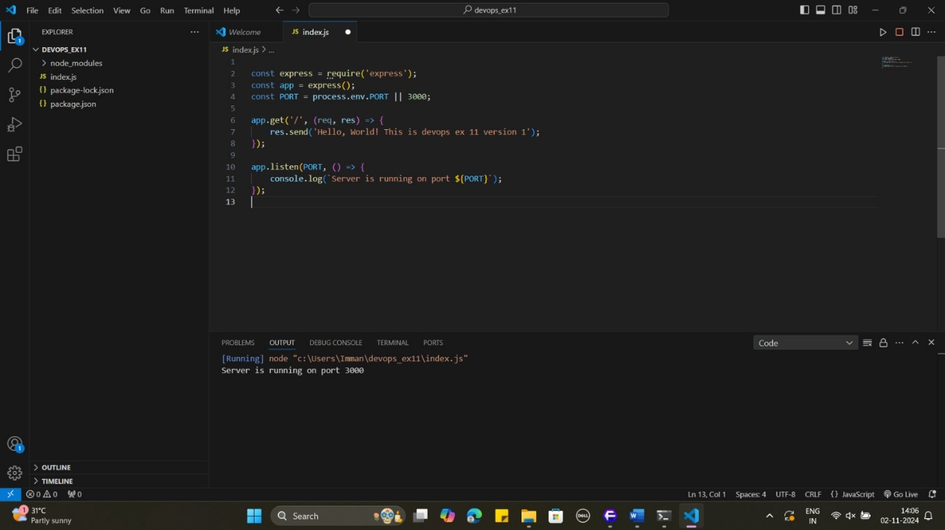

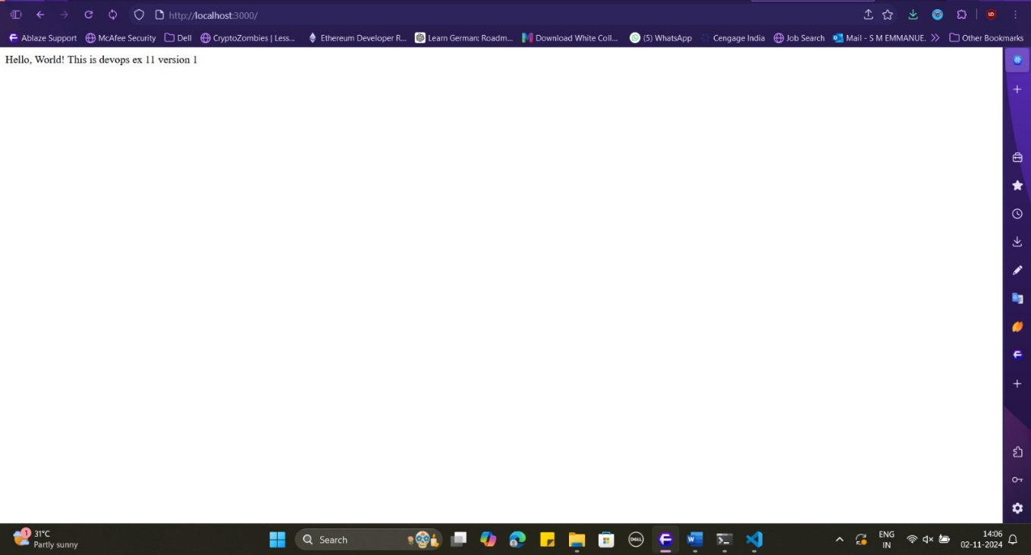

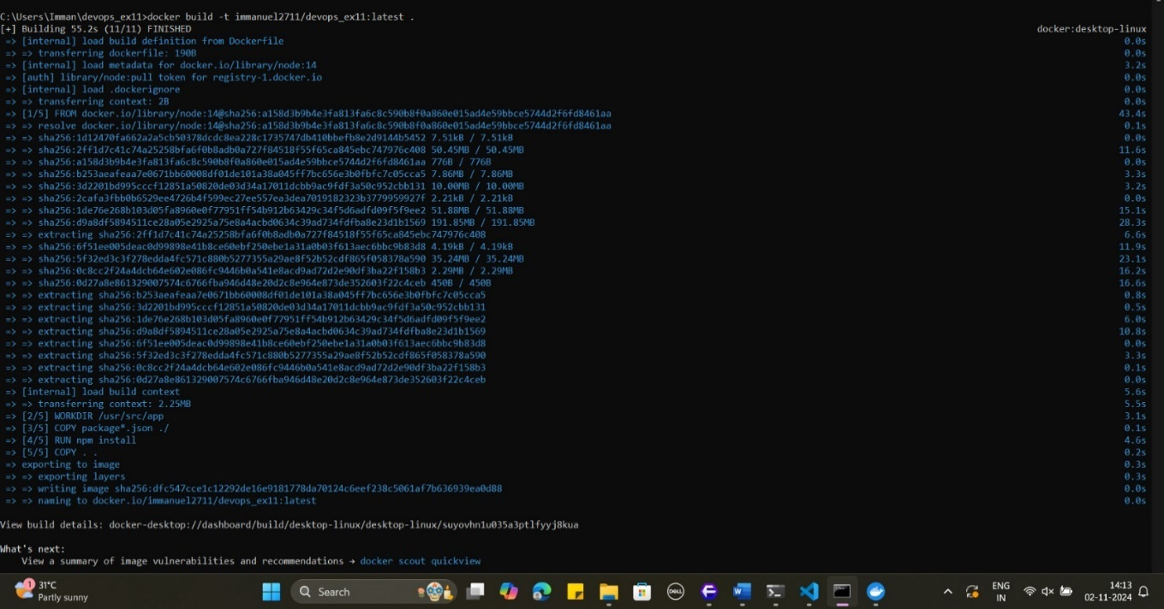

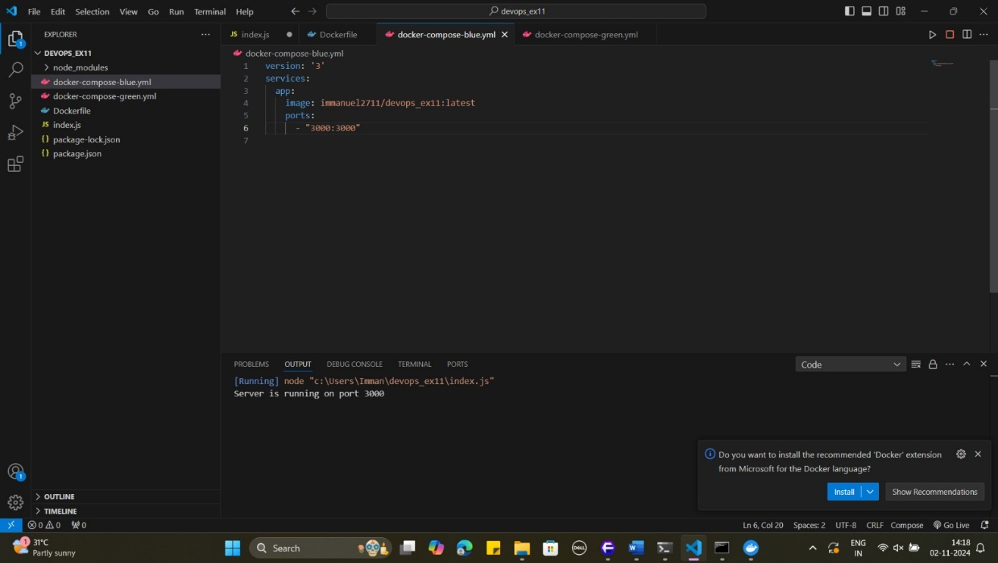

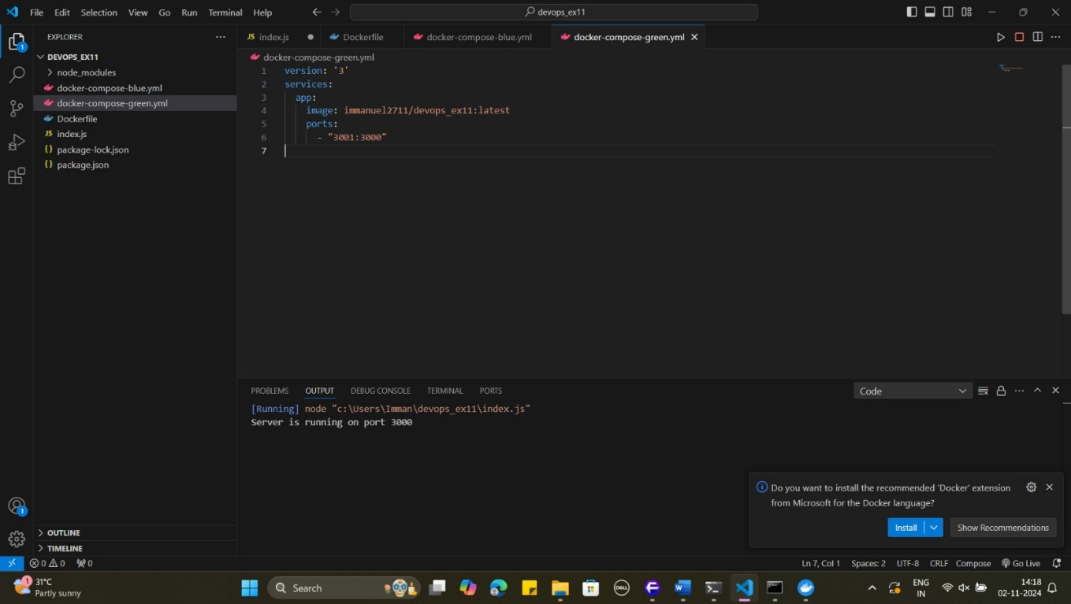

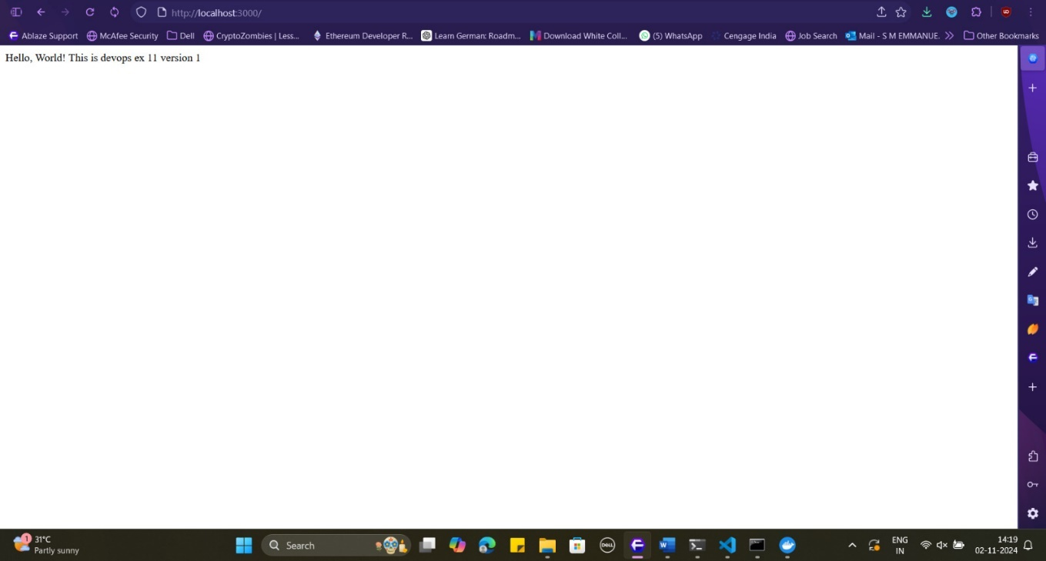



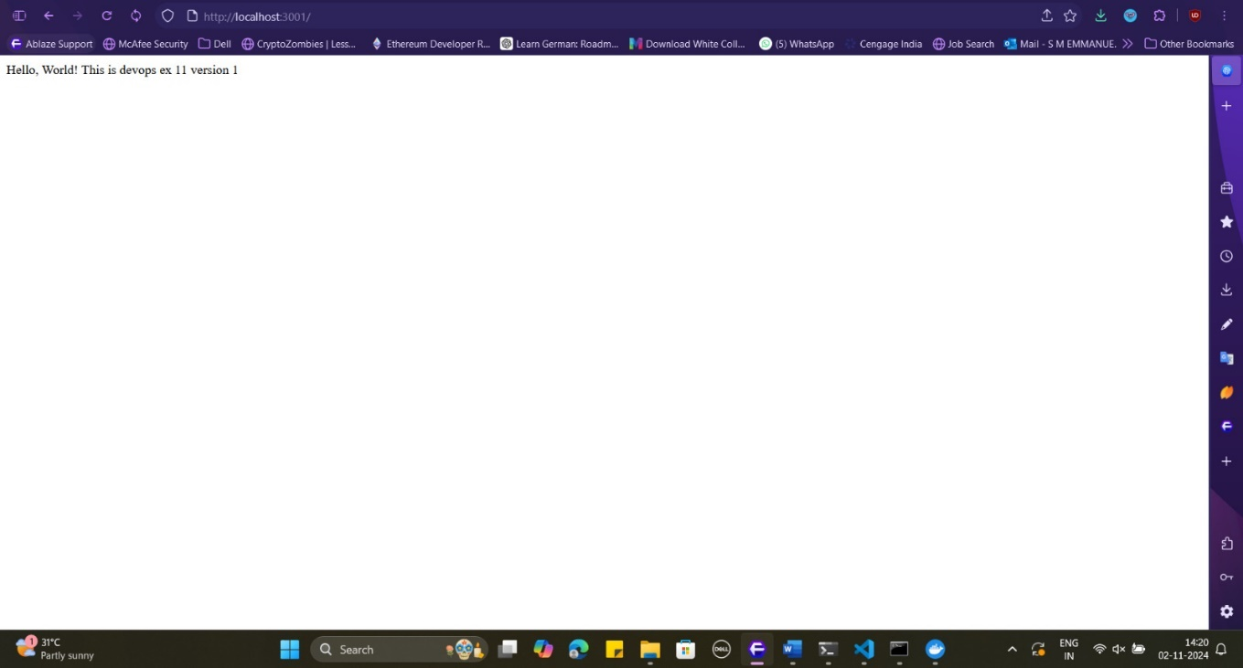

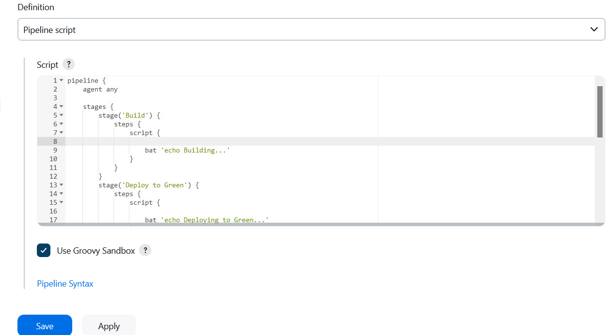

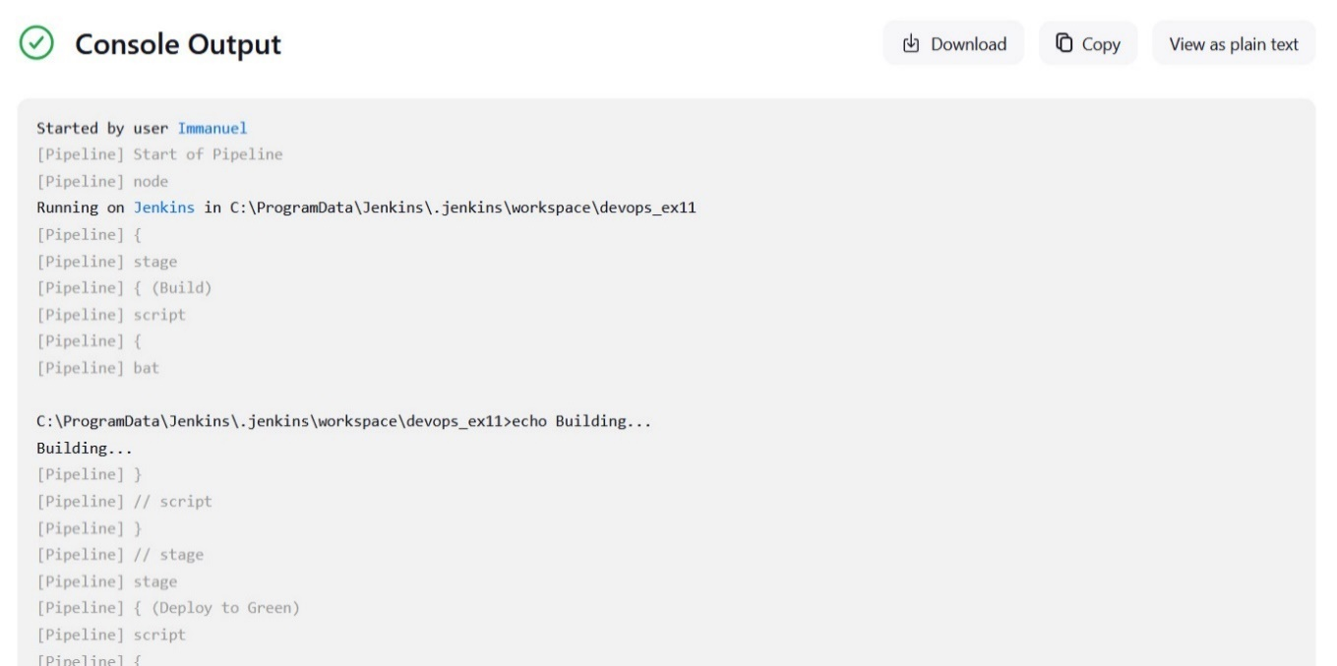

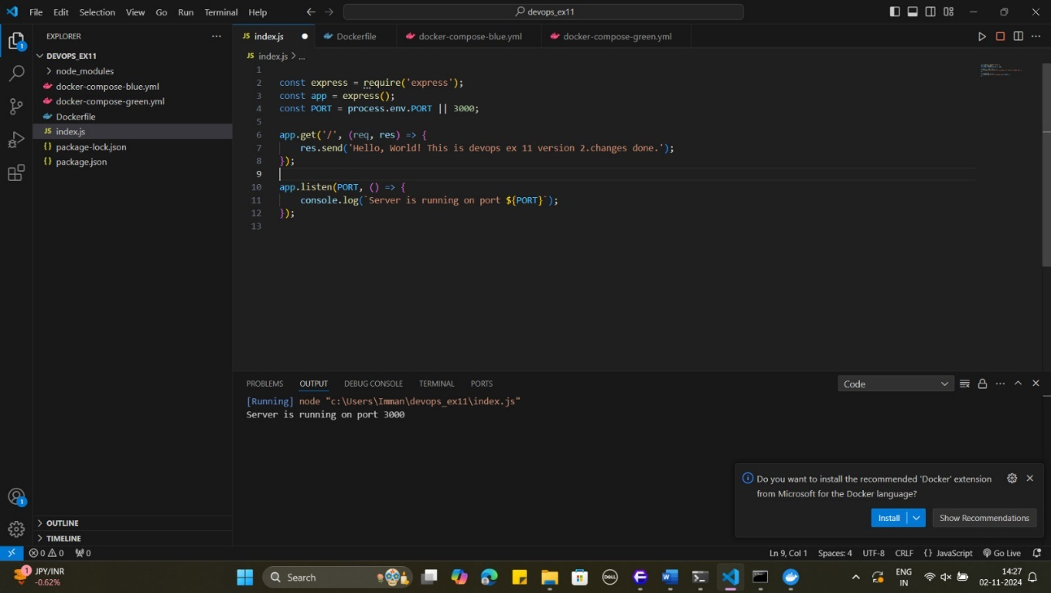



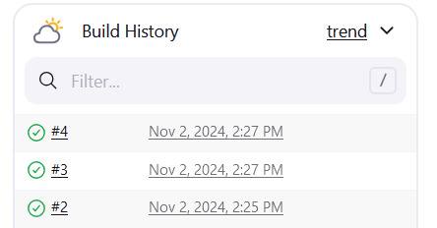

**RESULT:** Blue-green deployment was successfully implemented.